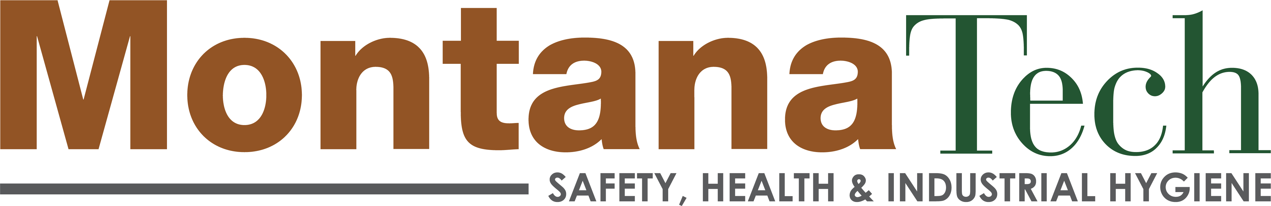
Industrial Hygiene Distance Learning/Professional Track
Oral Comp Exam Signature Sheet

Student Name:
Student ID: | Date:

has successfully completed the IH oral comprehensive examination of as a partial fulfillment for the Master of Science in Industrial Hygiene Distance Learning/Professional Track degree on this __ day of August, 2023.

Committee Member: | Signature:

*Per course syllabus: At least two MS IH faculty members will be present for the oral exam. A passing score on the oral exam is considered when the exam committee rates the overall responses as adequate or above. If a discrepancy occurs in the outcome of an oral exam (e.g., two faculty members are not in agreement), the exam recording will be reviewed by a third MS IH faculty member to determine the final outcome.

