Section 1 – Program Information
- Description of how the program contributes to the “Four-Lane Highway.”

Section 2 –Student Outcomes for Program
NWCCU’s standards for accreditation require that programs must “culminate in achievement of clearly identified student learning outcomes.” (1.C.1.)

Section 2a – Student Outcomes for Program
In this section, list the Student Outcomes for the program exactly as they appear in the Catalog.

Section 2b – Narrative
In this section, describe any changes made to the Student Outcomes since the last program review and the rationale for those changes. If no changes have been made to the Student Outcomes for the program, please indicate this.

Section 3 – Curriculum Map
NWCCU’s standards for accreditation require that programs must demonstrate “an appropriate breadth, depth, sequencing, and synthesis of learning” of student learning outcomes. (1.C.2)
In this section, provide a copy of the curriculum map for the program in tabular format. A template for the curriculum map is provided in the Excel spreadsheet.

Section 4 – Assessment
NWCCU’s standards for accreditation require that institutions engage in “an effective system of assessment to evaluate the quality of learning in its programs” that “recognizes the central role of faculty in establishing quality, assessing student learning, and improving instructional programs.” (1.C.5.)

Section 4a – Assessment Plan
In this section, provide a description of performance indicators/metrics used to assess student outcomes in the program. This description is a snap-shot in time of the assessment processes currently used in your department. The assessment plan should include the following information:
- Descriptions of the type of data collected for each performance indicator/metric. If a rubric is used to assess learning, then include the rubric as an appendix. If not all students in the program are assessed, describe how a representative sample of students is ensured.
- Descriptions of the performance target ranges for each performance indicator/metric. Each performance indicator/metric should have a performance target defined that quantifies performance as Below Target/Needs Improvement, Target/Satisfactory, and Above Target/Excellent.

Section 4b – Assessment Results
Create a table for all Student outcomes and performance indicators/metrics. A template is provided in this Excel spreadsheet. It is recommended that each performance indicator/metric be assessed at least twice in a six-year period. The Assessment results should include the following for each performance indicator/metric:
- Expected outcome for the performance indicator/metric
- Actual outcome for the performance indicator/metric over the time-period covered by the program review
- Number of students assessed
- Rating based on the performance target ranges for the performance indicator/metric (e.g. Below target, At target, Above target)
- Timeline describing when each performance indicator/metric was assessed

Section 5 – Action Plan
NWCCU’s standards for accreditation require that institutions “uses the results of its assessment efforts to inform academic and learning support planning and practices.”(1.C.7.)

Action plans should be generated when:
  - Student Performance on an outcome is below target.
  - Equity Gaps of student success in the program are identified for a particular student group.
  - A need is identified through student perspective data or external evaluators such as advisory boards.
  - Faculty want to explore something innovative in the program.
Action plans should include the following information:
- Description of the identified need
- The actions planned to address the identified need
- The person/group accountable for the action
- Any resources required
- How the actions will be evaluated

A template for Action Plans is provided in the Excel spreadsheet.
Appendix A – Example Curriculum Map (section 3)

Appendix B – Examples for Assessment Plan (Section 4a)

Mechanical Engineering:
6. An ability to develop and conduct appropriate experimentation, analyze and interpret data, and use engineering judgment to draw conclusions
a. Have the ability to design and perform experiments
i. Metric: CW - Specific material grade from EGEN 306
ii. Metric: CW - Specific material grade from EGEN 336
b. Use engineering judgement to draw conclusions based on data analysis and interpretation
i. Metric: CW - Specific material grade from EGEN 306
ii. Metric: CW - Specific material grade from EGEN 336
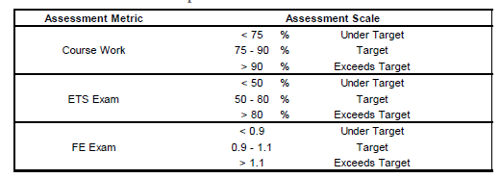

Appendix C – Example for Assessment Results (Section 4b)
Civil Engineering:
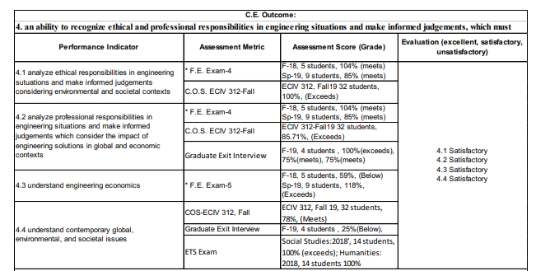

Nursing:
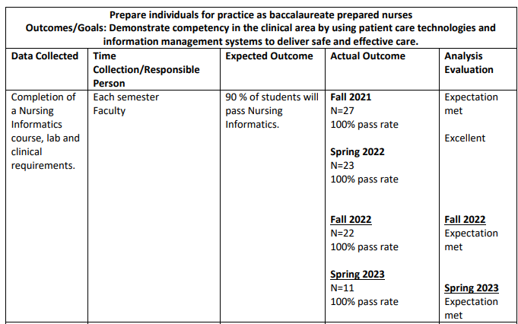
Appendix D – Example for Action Plan (Section 5)

Action Driver | Action Taken /# students impacted | Accountable Person | Resources Needed | Outcome Measure
Equity Gap for English as Second Language Learners | New peer review assignment in WRXXX implemented 2023-24 Fall | Instructor of WRXXX | Peer student lab grammar check | 2025 Certification Scores
PSLO2 Low Performance | Interprofessional survey course made mandatory for attendance for 2023-24 academic year | Program Director at Orientation makes the announcement | Collaboration with allied health majors | 2026 PSLO Re-measure

