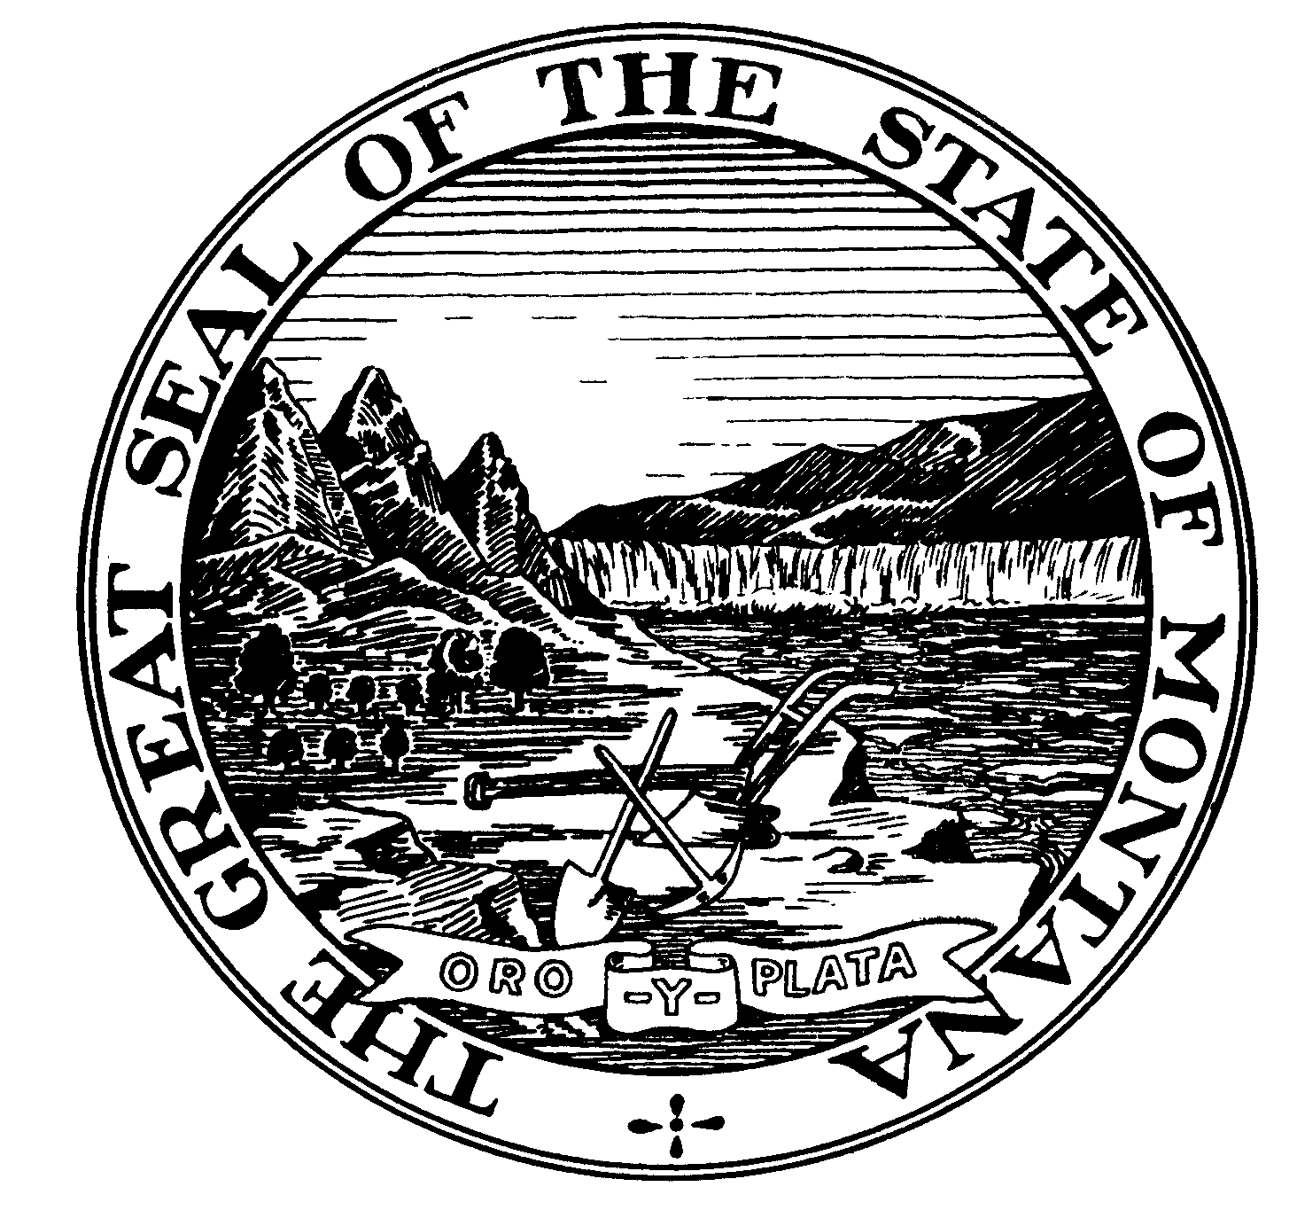MONTANA UNIVERSITY SYSTEM

Office of the Commissioner of Higher Education

2500 Broadway ◊ PO Box 203101 ◊ Helena, Montana 59620-3101 ◊ (406)444-6570 ◊ FAX (406)444-1469

Statement of Selective Service Registration Status

If you are a male, born after July 1, 1975, the Montana Compliance with Military Selective Service Act requires that you register with the Selective Service System unless you meet certain exemptions under Selective Service law. If you are required to register, but fail to do so, you are not eligible for employment with the Montana University System.

Non-registered Men Under Age 26

If you have reached your 18th birthday, are under age 26, and have not registered, you must register. The Montana University System is prohibited from hiring you unless you are registered.

Certification of Registration Status
Check one:

I certify that I am registered with the Selective Service System.
I certify that I am not required to register with the Selective Service Administration.

False Statement Notification

A false statement may be grounds for not hiring you, or for dismissing you if you have already begun work. Also, you may be punished by fine or imprisonment.

______________________________________ _____________________

Legal signature of individual Date signed

To register with the Selective Service or to obtain more information, visit the Selective Service System at www.sss.gov, call 1-847-688-6888, or write to:

Selective Service System
Registration Information Office

P. O. Box 94638
Palatine, IL 60094-4638

