Standard 4.A - Faculty Selection, Evaluation, Roles, Welfare, and Development

The selection, development, and retention of a competent faculty is of paramount importance to the institution. The faculty’s central responsibility is for educational programs and their quality. The faculty is adequate in number and qualifications to meet its obligations toward achievement of the institution’s mission and goals.

4.A.1 The institution employs professionally qualified faculty with primary commitment to the institution and representative of each field or program in which it offers major work.

Montana Tech recruits, rewards, and retains faculty who are both excellent instructors and active scholars. In the Fall of 2009, Montana Tech employed 176 full-time faculty and 91 part-time faculty. Of the tenurable full-time faculty, 53% are tenured. All non-tenure track faculty--whether full- or part-time--are considered to be adjunct. By this measure 52% of the full- and part-time faculty is adjunct. Of the full-time faculty, 50% hold a doctoral degree, usually a Ph.D., and 41% hold a Master’s degree. These degrees are either directly in or strongly related to the fields in which faculty teach and pursue research and scholarly activity. Of the tenure track instructional faculty teaching in B.S. programs, 70% hold a doctorate. Table 4.A.I summarizes the rank and tenure status of full and part-time faculty.

TABLE 4.A.I QUALIFICATIONS AND COMMITMENT OF THE FACULTY

 | Full-Time | Part-Time
Number Total | 176 | 91
Number Holding Doctorate | 88 | 7
% of 4 Yr Tenure Track Inst. Faculty With Doctorate | 70%
Number Holding Masters | 72 | 51
Tenured | 68
Probationary Tenure Track | 61
Data on the characteristics of the faculty is provided in the following exhibits and tables. Required Exhibit 4.A.I, Summary of Faculty Characteristics provides a current snapshot of the faculty at Montana Tech. Please also see Required Exhibit 4.A.II - Standard Four – Faculty Table 1 – Institutional Faculty Profile; Required Exhibit 4.A.III - Standard Four – Faculty Table 2 - Number and Source of Terminal Degrees of Faculty and the binders for Required Exhibit 4.A.IV, Standardized Resumes of Full-Time Faculty and Required Exhibit 4.A.V, Standardized Resumes of Part-Time Faculty that contain the current professional vitae of faculty at Montana Tech.

Table 4.A.II (on the following page) lists degrees of tenure track instructional faculty by department and does not include three administrators who hold faculty rank, but who do not regularly teach. Montana Tech also currently provides up to $1,500 in support per year for 11 faculty with Master’s degrees who are pursuing doctoral degrees

TABLE 4.A.II DEGREES OF TENURE TRACK
INSTRUCTIONAL FACULTY BY DEPARTMENT
Four Year Programs
Department | Doctorate | % Doctorate | Masters | Bachelors | Other
Biological Sciences | 6 | 85.7% | 1 | 0 | 0
Business & Information Technology | 1 | 20.0% | 4 | 0 | 0
Chemistry | 7 | 100.0% | 0 | 0 | 0
Computer Science | 3 | 60.0% | 2 | 0 | 0
Electrical Engineering | 4 | 100.0% | 0 | 0 | 0
Environmental Engineering | 6 | 85.7% | 1 | 0 | 0
General Engineering | 6 | 75.0% | 2 | 0 | 0
Geological Engineering | 5 | 100.0% | 0 | 0 | 0
Geophysical Engineering | 4 | 80.0% | 1 | 0 | 0
Health Care Informatics | 0 | 0.0% | 2 | 0 | 0
Liberal Studies | 9 | 100.0% | 0 | 0 | 0
Mathematical Sciences | 6 | 67.7% | 3 | 0 | 0
Metallurgical Engineering | 5 | 100.0% | 0 | 0 | 0
Mining Engineering | 4 | 100.0% | 0 | 0 | 0
Networking Technology | 0 | 0.0% | 1 | 2 | 0
Nursing | 0 | 0.0% | 8 | 0 | 0
Petroleum Engineering | 2 | 40.0% | 3 | 0 | 0
Professional & Technical Communication | 4 | 80.0% | 1 | 0 | 0
Safety, Health, & Industrial Hygiene | 4 | 67.7% | 2 | 0 | 0
TOTAL | 76 | 69.7% | 31 | 2 | 0
Two Year Programs
Department | Doctorate | % Doctorate | Masters | Bachelors | Other
Business Technology | 0 | 0.0% | 3 | 1 | 0
Trades & Technology | 0 | 0.0% | 1 | 4 | 1
Health Programs | 0 | 0.0% | 0 | 2 | 0
TOTAL | 0 | 0.0% | 4 | 7 | 1

In addition to instructional faculty, Montana Tech has a significant number of full-time faculty (17%) whose primary responsibility is research. The 30 full-time research faculty at Montana Tech are principally divided between 26 faculty in the Montana Bureau of Mines and Geology (MBMG) and three faculty in the Center for Advanced Mineral and Metallurgical Processing (CAMP).
As described in the MBMG web page, the Montana Bureau of Mines and Geology (MBMG) established in 1919, has as its mandate:

… to collect and publish information on Montana’s geology to promote orderly and responsible development of the energy, ground-water, and mineral resources of the State. A non-regulatory state agency, the Bureau provides extensive advisory, technical, and informational services on the States’ geologic, mineral, energy, and water resources. MBMG is increasingly involved in studies of the environmental impacts to land and water caused either by past practices in
hard-rock mining or by current activities in agriculture and industry.

The CAMP web page describes the mission of CAMP as:

The Center for Advanced Mineral and Metallurgical Processing will facilitate cooperation between the university system and industry to enhance the economy of the State of Montana by supporting, developing and adding value to the global mineral, metallurgical, and materials industry. Economic enhancement may be encouraged through added value processing of minerals, materials, and wastes while developing processes that minimize waste generation.

4.A.2 Faculty participate in academic planning, curriculum development and review, academic advising, and institutional governance.

Faculty play an active and often significant role in 37 of Montana Tech’s standing committees. Please see the Exhibit 4.A.VI, 2009-2010 Committee Roster and Table 4.A.III below. Table 4.A.III does not count ex-officio members and includes all committees with at least one faculty member. Currently faculty comprise 83% of the membership of academic committees and 57% of overall committee membership. Key faculty committees, such as the Faculty Senate, Curriculum Review Committee, Graduate Council, Research Advisory Committee, and Collegiate Evaluation Committee are composed almost completely of faculty members. Often, ad-hoc committees will have significant faculty membership. Recent examples include the Vision 2025 Committee (59% faculty) and the Merit Committee (89% faculty). Some of these committees are quite active and meet weekly, while others may meet only once a year or as needed. Generally, faculty members either volunteer for service on these committees or are elected or appointed from the faculty as a whole or from representative bodies such as colleges or departments. The minutes for some of these committees for the past year can be found in Exhibit 4.A.VII, Committee Minutes.

As an example of faculty involvement in curricular planning, consider the process by which a new course is added to the curriculum. The idea for a new course generally originates with a faculty member who will often have first taught the course as a special topics course, which has proven successful and generated a positive student response. This faculty member will then bring a request to the appropriate department to add this course to the curriculum. If the faculty members in the department agree with the request, a formal submission for a new course will be prepared. This formal submission will include a suggested course number, title, catalog description, and prerequisites; will have an attached syllabus; and will note known effects on other programs.

TABLE 4.A.III FACULTY PARTICIPATION IN STANDING COMMITTEES

Standing Committee | Total | Faculty
Academic Committees (largely)
Academic Freedom & Tenure Committee | 3 | 3
Academic Standards Committee | 5 | 3
Advising/Retention Committee | 20 | 6
Collegiate Evaluation Committee | 4 | 4
Curriculum Review Committee | 23 | 21
eLearning Committee | 15 | 10
Faculty Senate | 10 | 10
Faculty Service Committee | 3 | 3
General Education Review Committee | 18 | 16
Graduate Council | 16 | 16
Instructional Improvement Committee | 20 | 19
Library Committee | 22 | 20
National Awards Committee | 9 | 6
Research Advisory Committee | 14 | 14
Scholarship & Financial Aid Committee | 6 | 5
Student Disciplinary Appeals Committee | 7 | 5
Undergraduate Research Committee | 6 | 6
Non-Academic Committees (largely)
Athletic Committee | 8 | 5
Benefits Committee (Inter-Unit) | 2 | 1
Campus Access Committee | 22 | 2
Chancellor’s Advisory Committee | 22 | 6
Computer & Telecommunications Advisory Comm. | 29 | 13
Cultural Events Committee | 9 | 7
Educational Outreach Advisory Committee | 7 | 1
Employee Recognition Committee | 8 | 2
College Relations & Marketing Committee | 7 | 5
Financial Aid Appeals Committee | 7 | 2
Grievance Committee | 8 | 3
Motor Pool Committee | 5 | 2
Recycling Committee | 19 | 6
Safety Committee | 25 | 14
Strategic Planning Committee | 21 | 6
Student Union Activities Advisory Board | 11 | 1
Sustainability Committee | 12 | 6
Traffic & Parking Committee | 6 | 1
WEB Guidance Committee | 20 | 9
Wellness Committee | 21 | 9

(See Exhibit 4.A.VIII, Example Curriculum Review Request, from the Mathematical Sciences Department.) This formal request will then be vetted by the departments and the faculty in the college in which the request originated. If the college approves, the request passes to the Curriculum Committee, which has faculty representation from each instructional program. Once the request is approved by the Curriculum Committee, it is presented to the full instructional faculty for final approval. Clearly, the faculty own the curriculum.

In 2005 approximately half of the Montana Tech faculty associated with four year programs unionized as the Montana Tech Faculty Association (MTFA), which is affiliated with the MEA-MFT. Faculty who are not members of this union are principally--although not exclusively--engineering, nursing, and research faculty. Faculty in two year programs are represented by a different union, the Vocational-Technical Educators of Montana (VTEM), which is associated with the MEA-MFT, AFT, AFL-CIO. While these unions are primarily concerned with wages, benefits, and working conditions, to the extent that these concerns affect academic planning and governance (and they do), the MTFA and VTEM provide faculty represented by these organizations with another voice on these matters. The current collective bargaining agreements for these unions can be found in Exhibit 4.A.IX, MTFA-CBA, Montana Tech Faculty Association Collective Bargaining Agreement and in Exhibit 4.A.X, VTEM-CBA, Vocational-Technical Educators of Montana Collective Bargaining Agreement.

Montana Tech prides itself on involving faculty in mentoring and advising students. Tenure track instructional faculty advised a median of 13 students each in the fall 2009 semester. However, advising loads ranged as high as 124 students for one faculty in Petroleum Engineering, one of Montana Tech’s larger programs. At the time of enrollment and sometimes
earlier, while the student is still being recruited, a faculty member in the student’s major field is assigned as an advisor. Typically the initially assigned faculty member will advise these students throughout their course of study at Montana Tech, unless the student changes major, in which case a new faculty advisor in the new major would be assigned. While students are encouraged to visit with their advisors frequently, at a minimum students are required to meet with their advisors at least once a semester to register for the coming semester. Advisors are required sign drop add cards and to review and sign the student’s graduation forms. This approach to advising often results in the formation of lifelong friendships and professional
relationships between the faculty member and their advisees.

4.A.3 Faculty workloads reflect the mission and goals of the institution and the talents and competencies of faculty, allowing sufficient time and support for professional growth and renewal.

Workloads at Montana Tech are designed to insure that the faculty are able to provide “a strong undergraduate education augmented by research” as stated in the institution’s mission. The general increases in faculty participation in undergraduate research, in grant writing activity, and publication, as detailed in Standard 4.B, suggest that the current workload model provides sufficient time and resources for professional growth and renewal. The following provides the best single description of how workloads are established for faculty teaching in four year programs. Workloads for faculty in the four year programs are based on a 15 credits of workload per semester model which guides assignment of effort. For faculty for whom advising and service to the college are expected, 3 credits of this workload are automatically awarded for effort in these areas. Faculty members that are active in research and scholarship are normally able to claim 3 credits of workload for their efforts with the approval of their department head. New and recent faculty hires for whom demonstrated research and scholarship are requirements for promotion and tenure are generally accorded 3 credits of workload to allow for effort in this area. For a faculty member who is advising students, serving on college committees, and pursuing research/scholarship; this typically leaves 9 credits of workload to be devoted to instruction per semester. One credit of lecture (1 hour per week) counts as one credit of instructional load and one credit of laboratory (3 hours per week) counts as two credits of instructional load. The two credits of workload for a one credit laboratory has been negotiated into the most recent MTFA Collective Bargaining Agreement and is therefore contractual for faculty in the Collective Bargaining Unit. Of course, while the unexpected and varying needs of the institution make strict compliance with these guidelines unrealistic, never-the-less, the workload model described above provides a benchmark that the institution strives to achieve. General discussion and guidance on establishing faculty workload is provided in Exhibit 4.A.IX, MTFA-CBA, Article 21, Workload. Workloads for faculty in Montana Tech’s two-year programs are higher at up to 16 credits of workload per semester, recognizing the lessened expectations and demands of scholarship for the faculty members in two-year programs. The workload for faculty teaching in two-year programs is normally all in instruction with faculty in these programs teaching, for example, up to 5 three credit courses per semester. General discussion and guidance on establishing faculty workload is provided in Exhibit 4.A.X, VTEM-CBA, Appendix C - Memorandum of Understanding Faculty Workload. The instructional workload of any faculty member in any semester can be examined by consulting Exhibit 4.A.XI, Montana Tech Course Schedules.

Closing the Loop

The allowance of 3 credits or one course per semester reduction in workload for faculty in four year programs that are actively pursuing scholarship or where there are expectations for scholarship, as is the case for new faculty, resulted from an institutional recognition that faculty needed time to effectively pursue scholarship. This institutional investment in faculty scholarship has resulted in an almost 4 fold increase in funded research over the past decade and is necessary if the institution is to fulfill its mission of providing “a strong undergraduate education augmented by research.”

4.A.4 Faculty salaries and benefits are adequate to attract and retain a competent faculty and are consistent with the mission and goals of the institution. Policies on salaries and benefits are clearly stated, widely available, and equitably administered.

Exhibit 4.A.II, Table 1, Institutional Faculty Profile; and Standard 4, Exhibit 4.A.XII Faculty Salary Data lists faculty salaries. The latter table has had names and programmatic affiliation removed to prevent identifying the salaries of individual faculty. Policies on salary are kept in the Montana Tech Personnel Office. A comparison of state salaries for tenure track instructional faculty (research faculty are not included) with College and University Professional Association (CUPA) National Faculty Salary Survey salaries in Table 4.A.IV shows that as an institution, with the exception of the rank of instructors, we lag behind our CUPA comparators.

TABLE 4.A.IV COMPARISON OF MONTANA TECH SALARIES WITH CUPA

Rank | Average Montana Tech Salary | Average Montana CUPA Salary | Percent of CUPA Salary
All Ranks | $60,308 | $72,889 | 83%
Professor | $73,042 | $96,316 | 76%
Associate Professor | $61,423 | $72,851 | 84%
Assistant Professor | $55,091 | $66,764 | 83%
Instructor | $47,506 | $46,957 | 101%

The total salary compensation listed above does not include administrative stipends, extra compensation, and grant derived salary that is not supplanting state salary. Of course, in making these comparisons regional differences in cost of living need to be kept in mind.

Salary increases at Montana Tech begin with the State of Montana pay plan which biennially establishes the average increases for all state employees. For the 2007-2009 biennial budget this increase was 3.6%. All raises and adjustments for promotions, inversions, and inequities are to come from this increase. Merit increases, when a Merit Plan is in place, will be funded outside of the state pay plan increase. For the 2007-2008 academic year the average increase for faculty teaching in four year programs was 3.42%. In the 2008-2009 academic year the average increase (exclusive of promotion, inversion, and inequity adjustments) for faculty teaching in four year programs was 3.42%; and for faculty covered by the Vocational-Technical Educators of Montana (VTEM) bargaining agreement it was 3.00%. In the climate of the current economic downturn, the only pay raise approved for state employees for the 2009-2011 biennium is a $450 cost of living increase for state employees earning less than $45,000
The normal increase to base salary for promotion or academic achievement is outlined in the Table 4.A.V:

TABLE 4.A.V SALARY INCREASES FOR PROMOTION
AND ACADEMIC ACHIEVEMENT

Promotion | Increase to Base Salary
Promotion to Full Professor | $6,000
Promotion to Associate Professor | $4,000
Promotion to Instructor III | $6,000
Promotion to Instructor II | $4,000
Obtaining Doctorate Degree | $3,000
Obtaining Masters Degree | $1,000
Obtaining Professional Engineering License | $1,000

As an example of how the salary of a typical faculty member would increase with time under Montana Tech’s current salary structure, consider a hypothetical faculty member with a doctorate hired at a starting salary of $50,000. After 20 years, assuming on-schedule promotions to associate and full professor, an average annual raise of 3%, and no merit increases, this faculty member would attain a salary of $102,841.

Faculty once they reach the rank of full professor, approximately nine years into their academic career at Montana Tech, are essentially subject to only state pay plan salary increases. This is the fundamental reason why salaries of full professors at Montana Tech are on average only 76% of CUPA, which generally increases at a faster rate than the state pay plan increases.

The Montana State University Board of Regents consulting policy, see Exhibit 4.A. XV, Montana State University Board of Regents Policy 404.1, Consulting Services – Faculty, also allows faculty to consult for up to 40 days per academic year. This consulting not only benefits the state and the faculty member (and ultimately students) through knowledge transfer, but also provides another mechanism by which faculty can augment their salary. Between May 2007 and May 2008, 15 Montana Tech faculty had active consulting forms on file indicating their intention to engage in consulting.

Over the previous five years, faculty retention--defined as full-time tenure stream faculty who neither resigned nor were terminated--averaged 94% across the institution. Faculty retention data by department or program is shown in the Table 4.A.VI below:

TABLE 4.A.VI FACULTY RETAINED FROM THE PREVIOUS FALL

 | Fall 2009 | Fall 2008 | Fall 2007 | Fall 2006 | Fall 2005 | 5 Yr Avg.
Montana Tech as a whole | 94% | 96% | 96% | 96% | 87% | 94%
Biological Sciences | 100% | 100% | 100% | 100% | 100% | 100%
Business & Information Technology | 100% | 80% | 80% | 80% | 80% | 84%
Business Technology | 100% | 100% | 100% | 100% | 100% | 100%
Chemistry & Geochemistry | 80% | 100% | 100% | 100% | 100% | 96%
Computer Science | 100% | 100% | 100% | 83% | 50% | 87%
Electrical Engineering | 100% |  |  |  |  | 100%
Environmental Engineering | 100% | 100% | 100% | 100% | 100% | 100%
General Engineering | 100% | 89% | 89% | 100% | 89% | 93%
Geological Engineering | 75% | 100% | 100% | 100% | 100% | 95%
Geophysical Engineering | 100% | 100% | 100% | 100% | 80% | 96%
Health Care Informatics | 100% | 100% | 100% | 100% | 0% | 80%
Health Programs | 67% | 100% | 100% | 100% | 50% | 83%
Information Technology & Design | 100% | 100% | 100% | 67% | 33% | 80%
Liberal Studies | 100% | 100% | 100% | 100% | 100% | 100%
Lineman Program | 50% | 100% | 100% |  |  | 83%
Mathematical Sciences | 100% | 100% | 100% | 100% | 100% | 100%
Metallurgical Engineering | 80% | 100% | 100% | 100% | 100% | 96%
Mining Engineering | 100% | 100% | 100% | 100% | 75% | 95%
Nursing | 100% | 100% | 100% | 100% | 90% | 98%
Occupational Safety & Health | 100% | 100% | 100% | 100% | 100% | 100%
Petroleum Engineering | 100% | 88% | 86% | 100% | 80% | 91%
Professional & Technical Comm. | 100% | 83% | 83% | 83% | 83% | 86%
Trades & Technology | 80% | 75% | 75% | 80% | 80% | 78%

Closing the Loop

To best maintain competitive salaries, Montana Tech has:

- Distributed $202,061 among the base salaries of 40 full professors who were the furthest from CUPA, over the past three years. These adjustments have brought the full professors, as a group, closer to their CUPA average.

- Formed a Merit Committee composed of three faculty from the collective bargaining unit, three faculty outside the collective bargaining unit, and three administrators. This committee developed a procedure to identify meritorious faculty in four year programs and to distribute merit pay. A copy of the merit plan can be found in Exhibit 4.A.IX MTFA-CBA, Article 24, Merit Awards, and is also included in Exhibit 4.A.XXIII, Merit Plan. This plan has been ratified by the Montana Tech Faculty Association, but has yet to be approved by four year faculty outside the bargaining unit.

- Put in place a procedure so that faculty who have budgeted for academic year buyouts and/or summer salary at their current CUPA rate in externally funded grants are able to pay a portion of their salaries at the higher CUPA rate from these grants. This approach not only provides a mechanism to increase faculty salaries, but it also encourages faculty to seek external funding to support of their research and scholarship. Exhibit 4.A.XIV, Research Salary Policy, governs salaries paid for by sponsored research. During the 2008-2009 academic year, 14 Montana Tech full-time instructional faculty were paying some portion of their academic year salary from external grants. Please see Standard 4.B.5 for a more in depth discussion of how this policy works.

4.A.5 The institution provides for regular and systematic evaluation of faculty performance in order to ensure teaching effectiveness and the fulfillment of instructional and other faculty responsibilities. The institution’s policies, regulations, and procedures provide for the evaluation of all faculty on a continuing basis consistent with Policy 4.1 Faculty Evaluation.

All faculty are evaluated annually at the departmental level. However, full-professors are only evaluated every three years, on a rotating basis, with approximately one-third of all the full professors being evaluated in any given year. These evaluations are based on a review by departmental members of a portfolio prepared by the faculty member who is under review. For review of part-time faculty, both the portfolio and the review only address the area of instruction.

Procedures and expectations for evaluation, tenure, and promotion of faculty in four year B.S. and M.S. granting programs at Montana Tech are covered in:

- Exhibit 4.A. XVI, Faculty Staff Handbook, Section 206, Evaluation, Promotion, and Tenure – North Campus Faculty for all faculty in four year B.S. and M.S. granting programs;
- Exhibit 4.A.IX, MTFA-CBA, Article 14, Faculty Evaluation, for faculty in four year B.S. and M.S. granting programs, who are part of the MTFA Collective Bargaining Unit (where The Faculty Staff Handbook and the MTFA-CBA differ, the MTFA-CBA takes precedence);
- Exhibit 4.A. XVI, Faculty Staff Handbook, Section 207, Evaluation, Promotion, and Tenure –COT Faculty for faculty in the certificate and two year programs in the College of Technology (COT);
- Exhibit 4.A.X, VTEM-CBA, Article 7, Faculty Evaluation, for faculty in the

- certificate and two year programs in the College of Technology (COT), who are part of the VTEM Collective Bargaining Unit (where The Faculty Staff Handbook and the VTEM-CBA differ, the VTEM-CBA takes precedence);
- Exhibit 4.A. XVI, Faculty Staff Handbook, Section 208. Classification and Promotion-Montana Bureau of Mines and Geology Professional Faculty and Staff for faculty and staff in the Montana Bureau of Mines and Geology (MBMG), a department of Montana Tech and a Montana State service agency; and
- Exhibit 4.A. XVI, Faculty Staff Handbook, Section 206.4 for part-time faculty who are expected to prepare an evaluation portfolio that only addresses instruction and that follows the same guidelines as full-time faculty.

On June 1, 2005 the Montana Board of Personnel Appeals certified the Montana Tech Faculty Association (MTFA), which is affiliated with the Montana Education Association - Montana Federation of Teachers (MEA-MFT). Thus the MFTA became the exclusive representative for the bargaining unit, which is comprised of all teaching faculty in four year programs on academic appointment, department head(s) and/or department chairpersons, and lab director(s) with faculty status at Montana Tech. This bargaining unit excludes library faculty, nursing faculty, faculty represented by the Vocational-Technical Educators of Montana (VTEM) bargaining agreement, part-time academic appointments of less than .5 (one-half) FTE, all employees of the Bureau of Mines and Geology, and faculty who are professional engineers (PE) or engineers in training (EIT). Also excluded are coaching staff, museum staff, deans, non-teaching management personnel, visiting faculty, research assistants, post-doctoral fellows, and researchers with academic rank who would teach less than .5 (one-half) FTE. The latest MTFA Collective Bargaining Agreement (CBA), which was ratified in October of 2009 and subsequently approved by the Montana Board of Regents, addresses issues and policies related to wages, benefits, and working conditions for faculty who are members of this bargaining unit. Those faculty in the bargaining unit who teach in four year programs offering B.S. and M.S. degrees are largely concentrated in the College of Letters, Sciences, and Professional Studies. However, there are faculty in the College of Letters, Sciences, and Professional Studies who are not in the bargaining unit, notably nursing faculty. Also a number of faculty in the School of Mines and Engineering are in the bargaining unit. Because of this, when the MTFA-CBA was first developed, care was taken to keep in agreement with policies and procedures set forth in the Faculty Staff Handbook. In any instance where the MTFA-CBA and the Faculty Staff Handbook are not in agreement, the MTFA-CBA, as a contract, will take precedent over the Faculty Staff Handbook. Faculty evaluation for faculty teaching in four year programs is addressed in Exhibit 4.A.IX, MTFA-CBA, Article 14, Faculty Evaluation. Faculty in two year programs are represented by the Vocational-Technical Educators of Montana (VTEM). Faculty evaluation for faculty teaching in four year programs is addressed in Exhibit 4.A.X, VTEM-CBA, Article 7, Faculty Evaluation.

As required by the Faculty Staff Handbook Section 206.4, the MTFA-CBA Section 22.311, and by the VTEM-CBA; faculty instruction in all courses is evaluated by students each time the course is taught. Students use a uniform campus-wide evaluation form that can be viewed in Exhibit 4.A.XVII, Montana Tech Course Instruction Evaluation Form. This form was developed by a faculty committee and agreed to by a vote of the general faculty. This student evaluation form solicits Likert scale responses to 25 questions that address instructional behaviors, and it also allows for free response to three general questions:

- What aspects of this course contributed to your learning?
- What aspects of this course did not contribute to your learning?
- Suggestions--What would you change to improve the course?

Finally the form allows departmental-specific questions to be added.

Required Exhibit 4.A.XVIII, Sample Real Course Evaluation (with the professor’s name and course identifying remarks removed) is a sample of an actual student evaluation. Faculty have on-line access to these evaluations, as do department heads for the faculty in their departments, deans for the faculty in their colleges, and the Vice Chancellor for Academic Affairs and Research (VCAA&R) for all faculty. If the evaluation has been filled out on-line, then the free responses are included in the on-line evaluation. On the other hand, if the evaluation was completed on paper, then the free responses are typed by departmental assistants and provided to the faculty and department head separately. In either case, academic administrators have appropriate access to the raw student evaluation data. Faculty members use these evaluations, every semester, to assess and improve the instruction in their courses. Moreover, these same evaluations are used by department heads, deans, the VCAA&R, and others in the evaluation cycle to help make decisions on promotion and tenure. Required Exhibit 4.4.XIX, On-Line Access to Student Evaluations, provides access to student evaluations for NWCC&U evaluators.

To give a flavor for faculty evaluation, the evaluation process for a tenure track assistant professor teaching in a four year program and undergoing mid-tenure review will be described. Since faculty are eligible to apply for tenure in their sixth year, for a tenure track faculty, who was given no time toward tenure at the time of initial appointment, mid-tenure review would occur during the faculty member’s third year at Montana Tech. The process would begin with faculty members preparing a portfolio addressing their accomplishments in the areas of instruction, research/scholarship, and service during their first three years at Montana Tech. The portfolio would contain a cover letter, letters of support from colleagues, copies of the faculty member’s three annual departmental evaluations, an up-to-date vita, summaries of courses taught and student evaluations from these courses, evidence of research and/or scholarly activity, and details of service to the department, college, profession, and community. The entire portfolio is due to the department head by October 1st. Based on the portfolio, the department head first solicits input from the tenured departmental faculty (although other faculty and staff may be asked to comment) and then writes a letter of support or non-support for the faculty member under review. The portfolio, the department head’s letter, and any additional evidence marshaled either by the department head or by the faculty member under review are forwarded to the dean of the respective college by November 1st. The dean reviews the portfolio, the department head’s letter, and any other relevant evidence. The dean then writes a letter of support or non-support and submits the entire package to the Collegiate Evaluation Committee by December 1st. Voting members of the Collegiate Evaluation Committee consist of two full-time, tenured, full professors. Two are elected from the College of Letters, Sciences, and Professional Studies; and two are elected from the School of Mines and Engineering. A fifth of voting faculty representative is selected by the faculty member under review. The Collegiate Evaluation Committee reviews the candidate’s materials, soliciting other information or seeking clarification as needed, and writes a positive, negative, or qualified recommendation before passing the review to the VCAA&R by February 21st. The VCAA&R, in turn, evaluates all of the aforementioned materials and recommendations and then forwards a written recommendation on to the Chancellor by March 15th. By April 1st the Chancellor ultimately affirms or denies previous assessments of the faculty member’s progress toward tenure, noting any areas of concern in a written reply to the faculty member. An example of a complete portfolio including letters from those reviewing the portfolio is included in Exhibit 4.A.XX, Faculty Promotion and Tenure Portfolio. At every stage of this process, faculty members may add to or modify their portfolio. Within seven calendar days of the completion of any stage of the process, faculty members under review are to be notified of the recommendations made at that stage. The process for applying for tenure or for promotion for instructors to Level II or III or for faculty to associate or full professor is essentially the same as that described above for mid-tenure review with the exception that the Chancellor’s recommendation is forwarded to the President of The University of Montana and then ultimately to the State of Montana Board of Regents. Please see Figure 4.A.1, Portfolio Flow Sheet, on the following page. It was developed by the Vice Chancellor of Academic Affairs and Research and is used to summarize the promotion and tenure process for faculty applicants and new hires.

Closing the Loop

In order to bring discipline-specific considerations into the evaluation process and to help insure uniformity in the application of standards as promotion and tenure portfolios move through the evaluation chain, departments at Montana Tech are currently developing Departmental Standards which, when finalized, will spell out the details by which faculty members applying for tenure or promotion from within a specific department will be judged. These evolving departmental standards are available as an appendix to Exhibit 2.A.I, Program Reviews.

4.A.6 The institution defines an orderly process for the recruitment and appointment of full-time faculty. Institutional personnel policies and procedures are published and made available to faculty.

Personnel policies and procedures are available in the Montana Tech Personnel Office and on the Human Services page of the Montana Tech website, http://www.mtech.edu/hr/. A binder containing some of the more relevant of these policies and procedures, including those addressing recruitment, has been provided as part of Required Exhibit 4.A.XXII, Personnel Policies and Procedures. Policies and procedures governing recruitment of faculty and staff are addressed in Exhibit 4.A.XVI, Faculty Staff Handbook, Section 204, Recruiting and Selecting New Faculty and Section 501, Hiring Procedures; in Exhibit 4.A.IX, MTFA-CBA, Article 10, Recruiting and Selecting of New Faculty; in Exhibit 4.A.X, VTEM-CBA, Article 9.5, Extended Postings and Hiring Between Colleges; and documents available in the Montana Tech Personnel Office and on the Montana Tech website, http://www.mtech.edu/hr/Recruitment.html.

Recruitment begins when the need to hire a full-time faculty member arises at the department level and is typically in response to a retirement, resignation, leave of absence, termination, or sometimes a sabbatical. With advice from the dean of the college, the department prepares a formal Personnel Request Application (PRA) for the position. An example of a blank PRA is presented in Exhibit 4.A.XXIII, PRA Form. The PRA is then brought to the Dean’s Council, where the discussion centers on balancing departmental needs with those of the institution.

If the PRA is approved by the Dean’s Council, the request for a faculty hire results in the PRA being forwarded to the Executive Budget Committee, where the impact of the hire on the institution’s finances is considered. Montana Tech’s Personnel Office is actively involved in this process to insure compliance with Affirmative Action and Equal Opportunity rules and regulations.

An active PRA requires signatures by the Department Head, Dean, Vice Chancellor for Academic Affairs and Research, by the Affirmative Action/EEO Officer, Vice Chancellor for Fiscal Administration, and, ultimately, by the Chancellor. An example of a recent PRA is included as part of Exhibit 4.A.XXIV, Example PRA.

Once fully approved, the requested position is posted on the Montana Tech website under employment and advertised locally, regionally, and/or nationally as appropriate. A snapshot of the Montana Tech employment web site is provided in Exhibit 4.A.XXV, Montana Tech Employment Web Site. The text of the advertisement is part of the PRA and is largely written by the affected department with oversight from the Dean, from the Vice Chancellor for Academic Affairs and Research, and from the AA/EEO Officer. Appropriate venues for advertising the position are suggested by the department. In recent years, as advertising costs and time to publication have increased, Montana Tech has made greater use of electronic job postings.

Concurrent with advertising for the position a search committee is formed. The committee consists of at least three faculty members representing the academic department and one faculty member from outside the department. Student involvement is encouraged and may include a student member appointed by the Department Head to the search committee. The search committee and the chair of the committee, who is usually the affected department head, develop an applicant screening matrix of required and preferred criteria to help with the review of candidates. Just prior to the advertised date for reviewing applications, the search committee meets with the Equal Opportunity Officer to familiarize the search committee with the rules and regulations governing the search process.

The search committee then reviews applications and typically classifies these applications as Tier I, two to four candidates to be invited in for an interview; Tier II, potential candidates, if a hire doesn’t materialize from Tier I; and Tier III, candidates who are not to be considered further. At this point references are checked on Tier I candidates, interview arrangements are made for Tier I candidates, and Tier III candidates are notified that they are no longer being considered. Interviews typically require one to two days, during which the candidate meets with the department and other interested faculty, with students in the affected majors, with a representative of the Personnel Office, and with the Dean of the College The candidate also meets with the Associate Vice Chancellor for Research and Graduate Studies, the Vice Chancellor for Academic Affairs and Research, and, of course, with the search committee. Normally, the candidates will present a seminar in their field of scholarly interest to interested faculty and students. This seminar is effective in judging the candidate’s ability to teach.

After the search committee makes its recommendation, the Department Head, Dean, and Vice Chancellor for Academic Affairs and Research construct an offer of employment. The offer details salary, credit toward promotion and tenure, moving expenses, and any other conditions of the initial hire. Guidelines on allocation of moving expenses can be found in Exhibit 4.A.XVI, Faculty Staff Handbook, Section 501, Relocation Expenses. Montana Tech may offer one to two years toward promotion to associate professor and one to two years (rarely) toward tenure for prior experience that the candidate has in a tenure track position at an accredited college or university. When circumstances require us to hire a candidate with a master’s degree (where the doctorate is the normal terminal degree), we may in the letter of appointment require the
new hire to complete an appropriate doctorate as a condition of promotion or tenure. Upon the Chancellor’s approval, the candidate is notified of the offer. If the candidate accepts the offer, the remaining candidates are notified that the position has been filled. Meanwhile, the new hire’s completed search file is forwarded to the Montana Tech Personnel Office for archiving.

4.A.7 The institution fosters and protects academic freedom for faculty. Eligibility Requirement 11 and Policy A- Practices Regarding Institutional Mission and Goals, Policies and Administration.

The institutional setting for academic freedom at Montana Tech is described well in the introduction to Section 203, Faculty Code of Conduct in the Faculty Staff Handbook, (see Exhibit 4.A. XVI, Faculty Staff Handbook, Section 203, Faculty Code of Conduct).

“The Institution is devoted to the pursuit of learning in the broadest sense. Its public responsibilities include the transmission of learning, the creation of knowledge, and the performance of services in related endeavors. Traditionally, colleges have served not only as transmitters of learning and repositories of knowledge, but also as institutions for the development of that innovation and criticism without which civilization cannot progress. In the fulfillment of these traditional obligations, the Institution and its members are occasionally put in a position of apparent conflict among themselves and society. It is sometimes inevitable that new knowledge should find itself at odds with the old. Experimentation with new ideas and criticism of society is the inevitable and desirable result of a properly functioning institution.”

“These conflicts between the Institution and the community, and within the Institution itself, must not be allowed to interfere with the effective operation of the Institution. It is essential that the membership of the Institution be guaranteed freedom of expression, inquiry, association, criticism, and dissent without fear of reprisal, bodily harm, or physical disorder. The responsibility of maintaining academic freedom is shared by the Institution and through the persons of its students, its faculty, its administrators and its regents and by society.”

Montana Tech’s policies on academic freedom are based on the Montana Board of Regents Policy 302, which can be found in Exhibit 4.A.XXVI, Montana Board of Regents Policy 302. This policy, in turn, is based on the 1940 Statement of Principles on Academic Freedom and Tenure of the American Association of University Professors that can be found both in Exhibit 4.A.XXVII, AAUP 1940 Statement of Principles on Academic Freedom and Tenure and in subsequent revisions of this statement. Montana Tech’s policies on academic freedom are specifically addressed in:

- Exhibit 4.A. XVI, Faculty Staff Handbook, Section 202, Academic Freedom and Section 203, Faculty Code of Conduct;
- Exhibit 4.A.IX, MTFA-CBA, Article 9, Academic Freedom and Responsibility; and
- Exhibit 4.A.X, VTEM-CBA, Article 4.15, Academic Freedom.

Faculty members may appeal to the Academic Freedom and Tenure Committee in situations where they feel that their academic freedom has been impaired or threatened. This committee consists of only tenured non-administrative faculty members, who have been elected by the faculty. Moreover, this committee rarely has cause to meet.

4.A.8 Part-time and adjunct faculty are qualified by academic background, degree(s), and/or professional experience to carry out their teaching assignment and/or other prescribed duties and responsibilities in accord with the mission and goals of the institution.

Where possible, Montana Tech uses full-time faculty to provide instruction, thereby minimizing the use of part-time and adjunct faculty. In spite of this goal, the institution still finds it necessary to use part-time faculty for some instruction. The recruitment and selection of part-time faculty in four-year programs is explicitly addressed in the Exhibit 4.A. XVI, Faculty Staff Handbook, Section 204, Recruiting and Selecting Part-Time Faculty. In the fall of 2009, 91 part-time faculty provided 324 credit hours of instruction in 128 courses. The majority of part-time and adjunct faculty teach in the College of Letters, Sciences, and Professional Studies and in the College of Technology. Of the part-time faculty teaching in the fall 2008 semester, 8% held a terminal degree, usually a Ph.D., 56% held a Master’s degree, and 27% held a Bachelor’s degree. Please refer back to Table 4.A.I, and also, please see the following exhibits:

- Exhibit 4.A.II, Table 1 - Institutional Faculty Profile;
- Exhibit 4.A.III, Table 2 - Number and Source of Terminal Degrees of Faculty
- Exhibit 4.A.V, Standardized Resumes of Part-Time Faculty.

4.A.9 Employment practices for part-time and adjunct faculty include dissemination of information regarding the institution, the work assignment, rights and responsibilities, and conditions of employment.

Part-time and adjunct faculty play an important role at Montana Tech, not only giving the institution flexibility in meeting curricular demands, but also in providing the kind of expertise not in the full-time faculty, e.g., a nutrition course taught by a registered nutritionist. In general Montana Tech’s part-time faculty members enrich the full-time faculty. Adjunct faculty are those faculty who are not tenure track and include part-time faculty paid on a per course basis, visiting faculty, coaches (who may also teach as part of their duties) and research faculty, who may either be part-time or full-time.

New part-time and adjunct faculty participate in an orientation process and are provided an orientation packet which includes a copy of the Faculty Staff Handbook. The part-time faculty orientation packet is provided in Exhibit 4.A.XXVIII, Part-Time Faculty Orientation Packet. Part-time and adjunct faculty are subject to the same appropriate policies, as are full-time faculty. For example, the evaluation of part-time faculty who teach in four year programs is addressed in the Exhibit 4.A.XVI, Faculty Staff Handbook, Section 206.4 evaluation of part-time faculty. For both part-time and adjunct faculty, this evaluation is done each semester they teach, is based only on instructional performance, and is governed by the same requirements that apply to full-time faculty in the area of instruction.

Two categories of part-time faculty are not eligible for benefits: 1) those who teach less than 15 credits per year and 2) those who teach less than 18 credits per year and are members of the VTEM bargaining unit. Currently, part-time instruction is paid at $832 per credit hour for lecture courses and $1,664 per credit hour for laboratory courses. The higher rate for laboratory courses reflects the increased contact time (typically 3 hours) required per credit.

Part-time faculty are generally not expected to serve on institutional committees or pursue scholarly research; however, they are welcome to participate in both, if they wish.

Closing the Loop

In order to insure that part-time and adjunct faculty are informed with respect to the institution, to work assignment, to rights and responsibilities, and to conditions of employment, Montana Tech created a Part-Time Faculty Orientation Packet that is currently given to new faculty during a new faculty orientation conducted by the Vice Chancellor for Academic Affairs and Research (see Exhibit 4.A.XXVIII, Part-Time Faculty Orientation Packet.

4.A.10 The institution demonstrates that it periodically assesses institutional policies concerning the use of part-time and adjunct faculty in light of the mission and goals of the institution.

While there are no formal procedures for assessing institutional policies as they affect part-time faculty, discussion concerning these policies can be initiated at any time by a variety of groups, including, for example, the Faculty Senate, the Dean’s Council, the Chancellor’s Cabinet, etc.

Closing the Loop

To give a voice to part-time faculty and to recognize and reward their contributions:

- The Faculty Senate was expanded to include an elected representative from the part-time faculty; and

- One of the six annual Rose and Anna Busch Faculty Achievement Awards is designated for a part-time faculty member.

Standard 4.B - Scholarship, Research, and Artistic Creation

Scholarship, including research and artistic creation, is inherent in the work of faculty and students and is integrated in mutually supportive ways with instructional activities, regardless of the size or nature of the institution.

- Scholarship is systematic study of a chosen subject characterized by a high level of expertise, originality, critical analysis, significance, and demonstrability. Through scholarship, which may entail creation, application, synthesis, or transmission of knowledge, faculty acquire and sustain their expertise, thereby contributing to the validity and vitality of their teaching. Faculty scholarship is necessary to maintain effective instruction in all institutions of higher education. It also provides students the opportunity to observe and develop an understanding of scholarly activity.

- Research is scholarly activity directed toward constructing and/or revising theories, and creating or applying knowledge. Although not limited to graduate/research institutions, research is an essential and integral part of graduate education where it serves two principal functions: (1) it advances the frontiers of knowledge which, when disseminated, contributes to the welfare of society and ensures the viability of content in an academic discipline; and (2) it educates students in the methods of inquiry and prepares them for careers as scholars, researchers, or practitioners.

4.B.1 Consistent with institutional mission and goals, faculty are engaged in scholarship, research, and artistic creation.

Montana Tech faculty members work with both undergraduate and graduate students by pursuing both funded and unfunded research. For many of the faculty, research is funded by extramural funding sources that include state, federal and private sources. In an average year, over 100 proposals are written with a total value in the range of $20,000,000. Typically, over 60% of these proposals are funded. Research volume has constantly grown over the last two decades and has increased from less than $1,000,000 annually to the current value which approaches $9,000,000.

Figure 4.B.1 shows the total awards for fiscal years 2004 – 2008.

Figure 4.B.2 shows research expenditures for fiscal years 2004 – 2008.

Figure 4.B.3 illustrates the amount of campus grant writing for fiscal years 2004-2008.

Figure 4.B.4 provides a view of the level of engagement of the campus faculty in the research enterprise.

Moreover, Exhibits 4.B.I through 4.B.IV, contain the detailed Research Annual Reports for FY 2006 & 2007, FY 2005, FY 2004, and FY 2003 for the last five years.
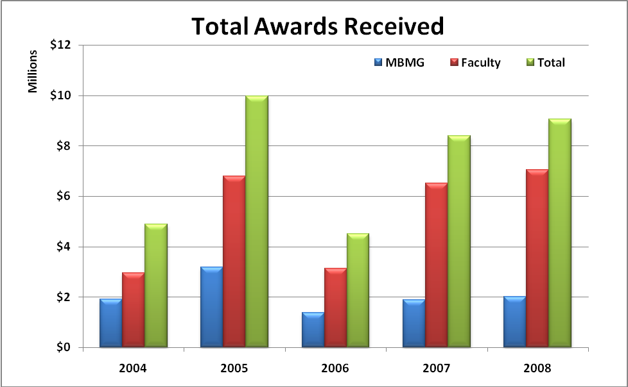

Figure 4.B.1: Total Awards Received FY2004 – FY2008

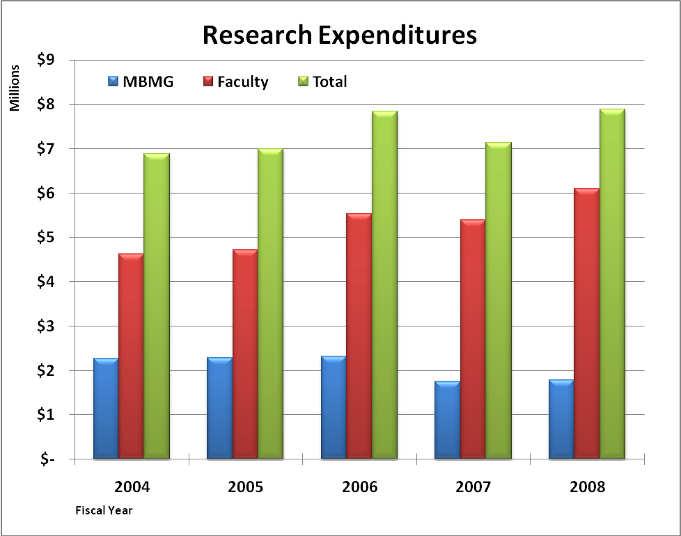
Figure 4.B.2: Research Expenditures FY2004-FY2008

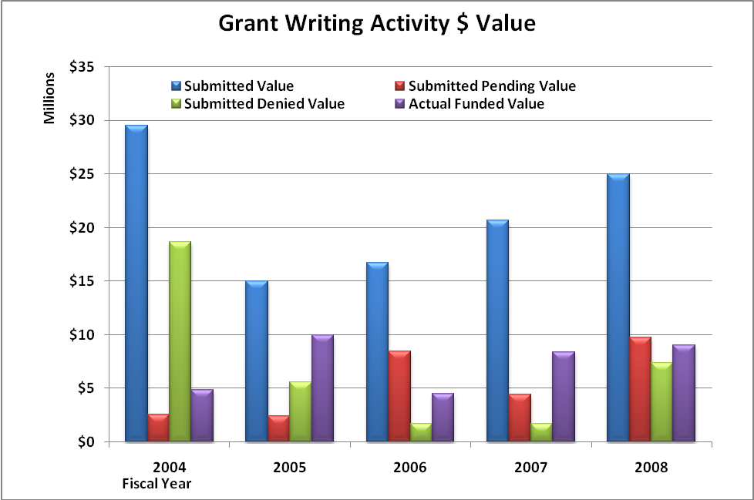
Figure 4.B.3: Grant Writing Activity for Fiscal Years 2004 to 2008

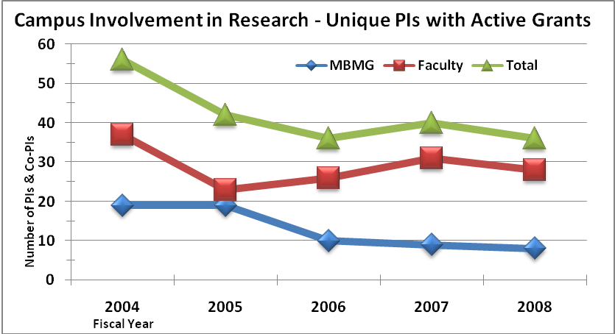
Figure 4.B.4: Campus Involvement in Research
A metric related to the receipt of funding is the number of publications that result from that funding. In a typical year, we have over 100 authors (39 individual faculty) in print. Figure 4.B.5 shows the last five years of publishing activity by tracking abstracts and presentations, publications in press, and works published. Note that “in press works” become “published works” in the following years. Exhibit 4.B.V, List of Published Scholarly Work (1999-2008) gives the complete list of faculty scholarly works for the last ten years.

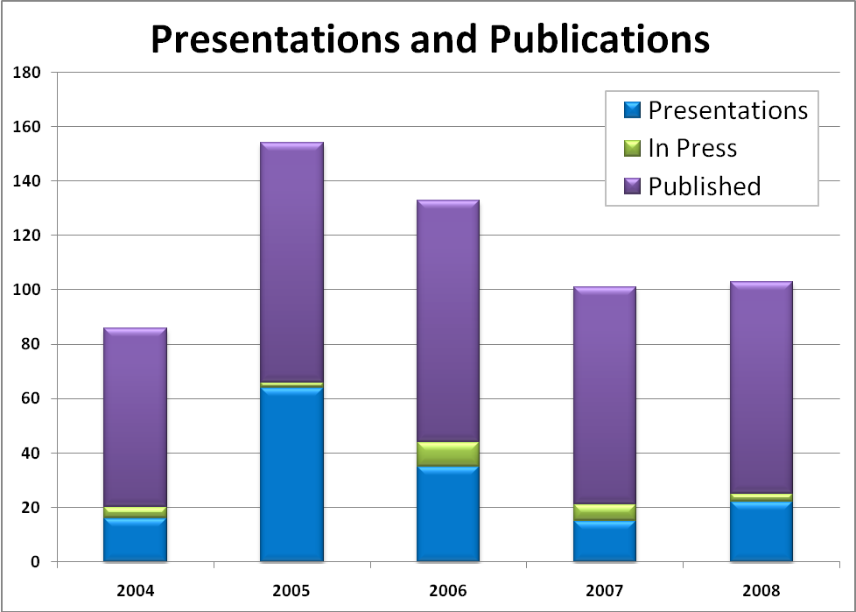

Figure 4.B.5: Publishing Activity

4.B.2 Institutional policies and procedures, including ethical considerations, concerning scholarship, research, and artistic creation, are clearly communicated.

Research and creative activities are governed by a set of standards and principles. Some originate from Montana Board of Regents Policy, some from Federal granting Agencies, and some from Montana Tech itself. In general, these policies govern the ethical conduct of research, conflict of interest, intellectual property, and the efficient and proper expenditure of funds. The relevant policies are referenced in Required Exhibits (Part 10) toward the end of this standard. In the past Montana Tech has oriented all new faculty on these topics. Because of a recent (2007) change in BOR policy, all faculty engaged in research now attend a mandatory 3 hour Principal Investigator (PI) training orientation on these topics. Exhibit 4.B.VI, PI Training Info Packet contains full Power Point presentations on the Pre-Award Process, the Post-Award Process, Intellectual Property and Technology Transfer, and Conflict of Interest. This PI orientation is typically offered at the start of the faculty contract period in the fall semester and is then repeated several times during the academic year.

In addition to the required PI training, all faculty are required to read, understand, and acknowledge the Montana Tech Conflict of Interest Policy. They are also required to fill out an annual declaration regarding potential conflicts of interest. If they have no conflicts of interest, they are also required to attest to this condition. The COI policy and forms are found in Exhibit 4.B.VII, Conflict of Interest Policy, Forms, and Definitions.

4.B.3 Consistent with institutional mission and goals, faculty have a substantive role in the development and administration of research policies and practices.

Montana Tech maintains two standing faculty committees that directly affect research and scholarship - the Graduate Council and the Research Advisory Committee which meet at least once a semester. The Statement of Purpose for both of these committees can be found in Exhibit 4.B.VIII, Graduate Council Mission Statement and Exhibit 4.B.IX, Research Advisory Council Mission Statement. Minutes for both of these committees for the last two years can be found in Exhibit 4.B.X, Graduate Council Minutes; Fall 2005, , Fall 2006, Spring 2007, Fall 2007 and Exhibit 4.B.XI, Research Advisory Council Minutes; Fall 2005, Fall 2006, Fall 2007, Spring 2008. Departmental representatives to each committee are nominated by the Department Head. The current membership of both committees can be found in Exhibit 4.B.XII, Graduate Council and Research Advisory Council Members.

4.B.4 Consistent with its mission and goals, the institution provides appropriate financial, physical, administrative, and information resources for scholarship, research, and artistic creation.

The Office of Research consists of two full-time employees and one half time position, which is sometimes filled by a student intern. This Office handles pre-award functions for the campus and works with the Office of Sponsored Projects to develop proposed budgets. In addition, the Office of Research provides initial management to new Centers, although the recent trend has been to assign successful Centers to a particular College for management purposes. The office organization is shown in Exhibit 4.B.XIII, Office of Research Organization Structure. The Office of Sponsored Projects handles all post-award activity for the campus. The office consists of three full-time employees. The office organization is shown in Exhibit 4.B.XIV, Office of Contracts and Grants Organization Structure. The Office of Research and the Office of Sponsored Projects posts all information relevant to pre-award and post-award information on the WEB at http://www.mtech.edu/research/policies/Policies_and_Procedures.html.

Faculty direct the Montana Tech Seed Grant program, which provides modest start-up monies to new faculty who are within two years of the date of their initial hire. In recent years, the typical grant maximum has been $5,000. Membership, policies, and recent activities of the Montana Tech Seed Grant program can be found in Exhibit 4.B.XV – Seed Grants Program Mandate; Exhibit 4.B.XVI – Seed Grants Committee Members; and Exhibit 4.B.XVII – Recent Seed Grant Awards.

The campus research infrastructure remains a challenge. The fast growth in research volume continues to put pressure both on good research space and adequate research office space. Major renovations in 1999 to the Chemistry and Biology Building, additions of research laboratories to the ELC in 1998 and the new Natural Resources Building begun in 2008 all help alleviate this problem, but issues still remain at the departmental level. Research equipment also remains a challenge. The MUS provides no support for research equipment so faculty must depended on the Federal Agencies or private investment to provide funds for equipment purchases. The campus still struggles to pay for O&M costs for this equipment.

The Office of Research has worked with departments, bureaus and Centers to identify focused investments of Montana Tech IDC generated funds to improve campus infrastructure. These investments typically range from $125,000 to $275,000 per year and have been used to upgrade existing laboratories or to purchase needed research equipment.

The Office of Research maintains a subscription email listing for all faculty engaged in research. This is used to send out notices of opportunities, Agency Call for Proposals and Broad Agency Announcements of upcoming grant opportunities. Information on meetings, seminars, and training of interest are also sent out by email to our research faculty.

The Research Office maintains an ongoing enterprise fund for proposal development. Typical uses include a faculty trip to meet with a program sponsor and discuss a potential proposal, a trip to meet co-investigators to prepare a joint proposal in response to a call for proposals, or a trip to attend a briefing by a specific agency.

4.B.5 The nature of the institution’s research mission and goals and its commitment to faculty scholarship, research, and artistic creation are reflected in the assignment of faculty responsibilities, the expectation and reward of faculty performance, and opportunities for faculty renewal through sabbatical leaves or other similar programs.

While not chiseled in any stone, Montana Tech’s workload policy for faculty in four year programs is based on 15 credits of load per semester. For full-time tenure track faculty 3 credits of load are automatically assigned to account for advising and institutional service. For probationary faculty, who are expected to develop an active/productive research/scholarship program in order to meet the standards for promotion and tenure, 3 credits of load may, with the Department Head’s approval, be assigned for this effort. This same criterion applies to research-active faculty. The remaining 9 to 12 credits of load are assigned to instruction. In the area of instruction one lecture credit equals one credit of load, and one laboratory credit equals two credits of load. The assignment of load for laboratory instruction reflects the increased contact hours involved in laboratory instruction and is consistent with Montana Tech’s policy of paying twice as much per credit for laboratory instruction, as for lecture instruction. Faculty who do not advise, who are not active in institutional service, and/or who are not active in scholarship and research are expected to assume higher instructional loads.

Faculty, who have budgeted part of their time for work on funded research grants, may buy out of the appropriate portion of their instructional duties. Faculty may choose to use their “research salary,” i.e., the appropriate College and University and Professional Association (CUPA) salary average for their rank and discipline, in preparing their grant applications, for they are competing nationally for funding against faculty who make up these CUPA salary averages. As an example of how this works, consider a research-active faculty Let us assume this person normally teaches 9 credits per semester, performs 3 credits per semester of research (total of 12 credits per semester), and earns a state salary is $60,000 per nine month year.., Let’s further assume they have a funded grant in which they have budgeted for one-third release of their teaching duties for the year at their CUPA or research salary of $90,000 per nine month year, With this 3 credit release time the faculty member’s teaching load would drop to 6 credits per semester. Since one quarter of this faculty member’s salary (3/12) would be paid at a rate of $90,000 per year and three quarters (9/12) would be paid at $60,000 per year, this faculty member would be paid a salary of $72,500 per nine month year. This increase in 9 month salary from $60,000 to $72,500 for faculty who are able to secure funded research grants provides an incentive for faculty to pursue research at this level.

Closing the Loop

Since Montana Tech has adopted a nationally based compensation model for faculty engaged in research, the participation in the campus research enterprise by faculty has continually increased - - over the last five years the number of research active faculty has nearly doubled.

In order to recognize and reward faculty scholarship, the Research Advisory Council in 2002 established the Distinguished Researcher award. This award recognizes outstanding faculty contributions in building a dynamic research enterprise on the campus. Montana Tech also developed a Distinguished Researcher Lifetime Award to recognize those senior faculty who had made notable and continuous contributions to our research efforts. Exhibit 4.B.XVIII, Distinguished Researcher Award Policy, Process, and Winners contains the operating guidelines for the process, the annual call for nominations, and a list of all of the awardees since the programs inception in 2002.

4.B.6 Sponsored research and programs funded by grants, contracts, and gifts are consistent with the institution’s mission and goals.

The campus places a major emphasis on learning by doing, as encoded in our tag line “Get Into It” and our vision to be “a leader … for undergraduate and graduate education and research.” Undergraduate and graduate research is an extremely visible and viable manifestation of this core value of the institution. Currently faculty are engaged in a wide variety of research and scholarly activities that reflect their own particular expertise. Students are drawn to these endeavors and the net result not only enhances the students’ education and expands but it also deepens the faculty members’ knowledge of his or her area of specialty. Montana Tech is primarily an undergraduate institution where faculty research involves significant participation by undergraduates. Nowhere is this more evident than in our Undergraduate Research Program (URP). The URP was established in 1995 to give undergraduate students the opportunity to participate in research at Montana Tech. This program receives major Federal support from the National Science Foundation, the National Institutes of Health, and the National Aeronautics and Space Administration. Additional support is provided industry and Montana Tech. The cyclical nature of the funding, particularly NSF grants, is reflected in the participation as shown in Figure 4.B.6.

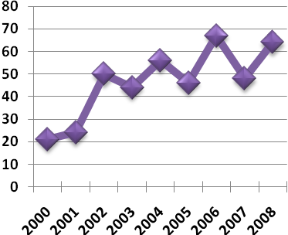

Figure 4.B.6 Undergraduate Research Participants

URP’s goal is to incorporate reality and excitement into the learning process by offering motivated students a hands-on-research experience which is guided by a faculty mentor. Here students gain valuable skills that enhance classroom learning and, at the same time, broaden their interaction with peers. In the URP, research is loosely defined and may include investigations of a cultural or historical question, documentary or production arts, or laboratory or field research typically associated with science or engineering disciplines.

The URP uses a proposal review process to select participants for the program. Each student is required to submit a proposal describing his or her research project. Proposals are reviewed by a faculty committee and the review process is loosely modeled after the National Science Foundation. However, it is greatly compressed in time so that unsuccessful applicants can respond to comments, make corrections or changes, and resubmit proposals for continued consideration in the current round of awards. The goal is to eventually make all proposals acceptable and, in some cases, has taken as many as four rounds of review. Selected students receive a $1,500 stipend and may be provided a research project. A research supervisor, such as a faculty or Montana Bureau of Mines and Geology member, sponsors and mentors each applicant and receives a stipend of $300. All URP students enroll in MT 4506, a one credit course that identifies successful recipients on their transcripts. In addition, all grant recipients are required to make an oral presentation of their work at the Undergraduate Research Fair held on the campus each April. Overall, the URP enhances the student learning experience through value-added skills in writing, in analyzing, in organizing, and in presenting research projects.

Closing the Loop – URP

The URP is now in its 14th year of operation, and the impact on student choices is becoming clear –- many more deciding to pursue advanced degrees. Since 1997 400 students have participated in the program. A major outcome of the program has been a tripling of the number of students going on for MS and PhD degrees. The campus wide average is 9%; the URP average is 25%.

Student participation in the URP has tripled over the years, and attendance at national conferences has increased to 10% of the participating students. We have also been successful in broadening participation beyond our science and engineering students so that we now have students from health sciences, professional and technical communications, and liberal studies. The URP Statement of Purpose, URP Guidelines, URP Charter, and recent URP awards can be found in Exhibit 4.B.XIX – URP Statement of Purpose; Exhibit 4.B.XX – URP Guidelines; Exhibit 4.B.XXI – URP Charter; and Exhibit 4.B.XXII – URP Recent Awards List (2007-08, 2006-07, 2005-06). Finally, the URP website http://www.mtech.edu/research/undergrad/undergraduate_research.html.

In order to track the diverse research activity of faculty; the Research Office maintains a data base of all submitted, denied, and awarded grants and contacts. Exhibit 4.B.XXIII; List of Research Proposals Submitted and Funded; 2004, 2005, 2006, 2007, 2008 summaries of all grants submitted in the last five years, sorted by academic department. Noted also is the outcome of that submittal. During this period, 520 grants have been submitted with a total value in excess of $107,000,000

Closing the Loop

Extra support provided to faculty members for grant preparation and for travel support to discuss their ideas with potential sponsors is having a positive effect. The number of submitted proposals has increased over the last five years, and the success rate is well over 50%.

During the past year (2008-2009), the College of Technology (COT) has developed an organizational structure and program to permit COT faculty to participate in modest, student-driven research. This trend is significant because COT faculty are not expected to conduct research. The program is entitled the Research, Creative & Scholarly Activity Grant program (RCSA). In its first year, , RCSA has sponsored two student-faculty research collaborations.

In addition to the broad range of research performed by individual faculty, Montana Tech supports several “Centers of Excellence” whose research agendas are more focused than a typical academic department. These Centers are authorized by the Montana Board of Regents, as per the BOR policies noted in Exhibit 4.B.XIV, Board of Regents Policy on Research Centers and Programs. Currently, Montana Tech has three Centers approved under these guidelines: the Center for Advanced Mineral and Metallurgical Processing (CAMP), the Center for Environmental Remediation and Assessment (CERA), and the Center for Advanced Supramolecular and Nano Systems (CASANS). Mission statements of these three Centers are included in Exhibit 4.B.XXV, Research Centers Mission Statements. The Research Office provides administrative oversight to CAMP and CASANS. The Dean of the School of Mines and Engineering provides management oversight to the CERA. CAMP maintains a WEB presence at http://www.mtech.edu/camp/.

Please see Standard 4, Required Documentation 4.5, for several examples of the institutional and public impact of faculty scholarship and Standard 4, Required Documentation 4.6 for a list of publications representing the most significant artistic creation, scholarly activity, and research by faculty during the past five years.

4.B.7 Faculty are accorded academic freedom to pursue scholarship, research, and artistic creation consistent with the institution’s mission and goals.

The institutional setting for academic freedom at Montana Tech is described well in the introduction to Section 203, Faculty Code of Conduct in the Faculty Staff Handbook. (See Exhibit 4.A. XVI, Faculty Staff Handbook, Section 203, Faculty Code of Conduct.) Section 203 reads as follows:

“The Institution is devoted to the pursuit of learning in the broadest sense. Its public responsibilities include the transmission of learning, the creation of knowledge, and the performance of services in related endeavors. Traditionally, colleges have served not only as transmitters of learning and repositories of knowledge, but also as institutions for the development of that innovation and criticism without which civilization cannot progress. In the fulfillment of these traditional obligations, the Institution and its members are occasionally put in a position of apparent conflict among themselves and society. It is sometimes inevitable that new knowledge should find itself at odds with the old. Experimentation with new ideas and criticism of society is the inevitable and desirable result of a properly functioning institution.”

“These conflicts between the Institution and the community, and within the Institution itself, must not be allowed to interfere with the effective operation of the Institution. It is essential that the membership of the Institution be guaranteed freedom of expression, inquiry, association, criticism, and dissent without fear of reprisal, bodily harm, or physical disorder. The responsibility of maintaining academic freedom is shared by the Institution and through the persons of its students, its faculty, its administrators and its regents and by society.”

(Please see Standard 4.A.7 for a more complete discussion of the protection of academic freedom at Montana Tech.)

In summary, Montana Tech has not only identified both strengths and opportunities for its faculty, but it has also identified areas in which it intends to move forward in faculty development.

Strengths

The growth in research and scholarly activity by instructional faculty over the past decade is clearly a strength of the Montana Tech faculty. During this period, the instructional faculty experienced a fourfold increase in annual funding and a threefold increase in the annual number of publications. A faculty, which is both research and scholarly active, synergistically compliments, informs, and stimulates teaching in concordance with our mission to “supply … a strong undergraduate curriculum augmented by research” and to “provide a quality education that blends theory with practice.” That this goal has been accomplished in the face of high teaching loads is a testimony to the dedication and hard work of our research-active faculty.

Opportunities

While Montana Tech has made several efforts to increase faculty salaries--including providing equity raises to full professors and pinning research salaries to peer averages--faculty salaries still lag behind national averages. Although the ability to raise faculty salaries is tied to external forces largely beyond the institution’s control (e.g., state budgets and the economy in general), Montana Tech needs to be ever vigilant in bringing faculty salaries closer to national averages. In addition, further continued growth in research and scholarly activity will require systematic and selective reduction in teaching loads.

Moving Forward

Moving forward, Montana Tech will:

- strive to recruit faculty who desire to excel both in the classroom and in research and scholarly activity;
- broaden the base of faculty who successfully pursue scholarship and research;
- seek funds to support merit increases in salary; and
- attempt to reduce teaching loads for research-active faculty who are supported by external grants.
Moving forward in this direction will enable Montana Tech to continue to fulfill a guiding principle of its mission, “To recruit, encourage, and enable faculty to develop regional and national reputations in teaching and research.”

Policy 4.1 Faculty Evaluation As stated in Standard Four, the effectiveness and quality of an institution’s total educational program depend upon the presence of a competent faculty. Further, it is the institution’s obligation, in consultation with the faculty, to evaluate the performance of its faculty members and to provide for their development on a continuing basis.

Standard Four also calls for faculty members to be safeguarded in their exercise of academic freedom. The protection of academic freedom does not lessen the need for performance evaluation of temporary or permanent members of the faculty to ensure, on a continuing basis, the effectiveness and quality of those individuals responsible for the academic program. This ongoing evaluation may take several forms, in accordance with the size, complexity, and mission of the institution, including, for example, annual merit salary evaluations of a significant nature, promotions, and/or tenure reviews, periodic post-tenure reviews, or reviews conducted in response to some institutional need. The requirement of this policy is that the accredited institution shall conduct a comprehensive evaluation of each faculty member in a regular and systematic manner at least once within each five-year period of service. The institution’s faculty evaluation process shall contain a provision to address concerns that may emerge between regularly scheduled evaluation activities.

In establishing a program of continuing faculty evaluation and in supporting a program of faculty development, institutions shall meet the following requirements:

a. Institutions develop collegially and implement internal plans and procedures that specify the process and criteria by which faculty members are evaluated on a continuing basis.

All Montana Tech faculty are evaluated annually, with the exception of full professors, approximately one-third of whom are evaluated every 3 years. Part-time faculty are evaluated at the end of each semester in which they teach, but are only evaluated on instruction. Detailed policies and procedures governing the evaluation of faculty are described in:

- Exhibit 4.A. XVI, Faculty Staff Handbook, Section 206, Evaluation, Promotion, and Tenure – North Campus Faculty for all faculty in four year B.S. and M.S. granting programs;
- Exhibit 4.A.IX, MTFA-CBA, Article 14, Faculty Evaluation, for faculty in four year B.S. and M.S. granting programs, who are part of the MTFA Collective Bargaining Unit (where The Faculty Staff Handbook and the MTFA-CBA differ, the MTFA-CBA takes precedence);
- Exhibit 4.A. XVI, Faculty Staff Handbook, Section 207, Evaluation, Promotion, and Tenure –COT Faculty for faculty in the certificate and two year programs in the College of Technology (COT);
- Exhibit 4.A.X, VTEM-CBA, Article 7, Faculty Evaluation, for faculty in the certificate and two year programs in the College of Technology (COT), who are part of the VTEM Collective Bargaining Unit (where The Faculty Staff Handbook and the VTEM-CBA differ, the VTEM-CBA takes precedence);
- Exhibit 4.A. XVI, Faculty Staff Handbook, Section 208. Classification and Promotion - Montana Bureau of Mines and Geology Professional Faculty and Staff for faculty and staff in the Montana Bureau of Mines and Geology (MBMG), which is a department of Montana Tech and a Montana State service agency; and
- Exhibit 4.A. XVI, Faculty Staff Handbook, Section 206.4 for part-time faculty who are expected to prepare an evaluation portfolio, which addresses instruction only and follows the same guidelines as full-time faculty.

All of the above documents had significant faculty involvement in their development and require appropriate faculty approval for their modification. (Please see Section 4.A.5 of this Standard for a more detailed discussion of faculty evaluation.)

b. Collegial participation in faculty performance evaluation is critical in order to bring subject matter and pedagogical knowledge substantively into the assessment process. Nonetheless, it is the obligation of the administration to ensure quality and effectiveness of the educational program through the evaluation of faculty performance. At a minimum, an institution’s evaluation plans must include administrative access to all primary or raw evaluation data.

Department Heads are encouraged to solicit written input from departmental colleagues on all evaluations of faculty and are required to solicit this input from tenured members of the department for annual probationary, promotion, and tenure evaluations. Examples of forms that can be used in soliciting this input are contained in Exhibit 4.A. XVI, Faculty Staff Handbook, Appendix B – Tenure Progress Report (Dept Faculty) and in Appendix C – Tenure Progress Report (Dept Head). Input from colleagues is based on a review of the faculty member’s evaluation portfolio. In addition to input from departmental and other colleagues, confidential external letters addressing the potential and accomplishments of the faculty member are required for promotion and tenure evaluations. Both the annual evaluations and the every 3rd year evaluations for full professors are carried out at the department level and administered by the Department Head (except in the case where the Department Head is being evaluated, when the Dean would administer the evaluation), with the final evaluation documents copied to the appropriate College Dean. Mid-tenure, tenure, and all promotion evaluations begin at the department level and progress to the Dean, Collegiate Evaluation Committee, Vice Chancellor for Academic Affairs and Research, and to the Chancellor. Within seven calendar days of forwarding the evaluation to the next stage, the affected faculty member is apprised of the positive or negative recommendation resulting from the evaluation at the previous stage. All promotion and tenure evaluations--except mid-tenure--are reviewed by the President of The University of Montana with which Montana Tech is affiliated. Ultimately promotion and tenure are granted by the Board of Regents that governs the Montana University System.

In all of these evaluations, the evaluation portfolio that was originally prepared by the affected faculty member and which contains much of the primary data on which the evaluation is based, is available for review by all faculty and administrators involved in the review process. In addition, the raw student course evaluation data are available to the faculty member and to appropriate administrators at the web-based course evaluation archive which can be viewed in Exhibit 4.A.XIX, On-Line Access to Student Evaluations.

c. Multiple indices are utilized by the administration and faculty in the continuing evaluation of faculty performance. Each of these data sources is to be related to the role of the faculty member in carrying out the mission of the institution.

Montana Tech’s mission requires that all faculty members demonstrate effectiveness in instruction, in scholarship and research, and in service. The evaluation of faculty in these broad areas is described in detail in Standard 4.A.5. Faculty members at the associate professor level or lower are evaluated annually, while full professors are evaluated every three years. Each of these evaluations begins with the affected faculty preparing a self-evaluation portfolio describing achievements and containing critical self-analysis of performance over the relevant time period. When the faculty member is undergoing review for promotion or for tenure, these self-evaluations may extend over a time period longer than the previous year. These portfolios, which contain summaries of the faculty member’s standardized student evaluations as well as an analysis of the faculty member’s contributions in research/scholarship and service, form the basis for peer review by the faculty member’s departmental colleagues and by others in the evaluative chain. These individual peer reviews are collected by the department head who provides a summary to the affected faculty member. In instances where the faculty member is under review for promotion or tenure additional review is solicited from faculty peers or others external to the department or college, who are in a position to comment meaningfully on the faculty member’s performance. An example portfolio with evaluations at all administrative levels for a faculty member who successfully applied for tenure is provided in Exhibit 4.A.XX, Faculty Promotion and Tenure Portfolio.

Some examples include:

1) The evaluation of teaching through student, peer, and administrative assessment.

- As required by the Faculty Staff Handbook, Section 206.4, the MTFA-CBA, Section 22.311, and by the VTEM-CBA faculty instruction in all courses is evaluated by students in each course each time the course is taught. Students are required to use the standardized student evaluation form, which can be viewed in Exhibit 4.A.XVII, Montana Tech Course Instruction Evaluation Form and which was developed by a faculty committee and agreed to by a vote of the general faculty.

- In addition faculty may opt to use Small Group Instructional Diagnosis (SGID) or may also use peer review to assess their instruction. Faculty are free to include the results of these approaches in summative evaluations of their teaching effectiveness. However, the use of these approaches is not required.

- Input on instructional effectiveness, which is based on close examination of data provided in the faculty member’s self-evaluation portfolio, is solicited from departmental faculty peers annually for all full-time faculty at the associate professor level or lower and every third year for full professors.

- Based on a review of the student and peer evaluations noted above and the faculty member’s self-evaluation portfolio, department heads provide a written summary of instructional effectiveness annually for all full-time faculty at the associate professor level or lower and every third year for full professors. Whenever the faculty member under review happens to be a department head, this summary is written by the appropriate College Dean.

2) The evaluation of the quality of scholarly performance and/or research productivity as reflected in peer judgments about publication and success in securing external funding.

- A faculty member’s effectiveness in scholarship and research is judged on the following:

- the number (mostly) and quality of publications;
- the number and venue of presentations;
- the involvement and mentoring of students in research;
- the number and dollar amount of funded research projects; and
- the number of grant applications,

as reflected in the faculty member’s self-evaluation portfolio and resume.

- Input on effectiveness in research/scholarship, based on an examination of the faculty member’s self-evaluation portfolio, is solicited from departmental faculty peers. This process is carried out annually for all full-time faculty at the associate professor level or lower and every third year for full professors.

- For faculty undergoing review for tenure and promotion, input on a faculty member’s effectiveness in scholarship and research is solicited from faculty peers external to the department and/or the College involved.

- Based on a review of the peer evaluations noted above and the faculty member’s self-evaluation portfolio, department heads provide a written summary of the faculty member’s effectiveness in scholarship and research annually for all full-time faculty at the associate professor level or lower and every third year for full professors. Whenever the faculty member under review happens to be a department head, this summary is written by the appropriate College Dean.

3) The evaluation of service to the profession, school, and community.

- A faculty member’s effectiveness in service to the profession, institution, department, and to the community is judged on activities noted in the faculty member’s self-evaluation portfolio and resume.

- Input on a faculty member’s effectiveness in service, which is based on close examination of information found in the faculty member’s self-evaluation portfolio, is solicited from departmental faculty peers. This process is used annually for all full-time faculty at the associate professor level or lower and every third year for full professors.

- Input on a faculty member’s effectiveness in service may be provided by or solicited from faculty peers, staff, or administration, who are external to the department and/or from others who are external to Montana Tech.

- Based on a review of the peer and other evaluations noted above and the faculty member’s self-evaluation portfolio, department heads write a summary of a faculty member’s effectiveness in service. This is done annually for all full-time faculty at the associate professor level or lower and every third year for full professors. Whenever the faculty member under review happens to be a department head, this summary is written by the appropriate College Dean.

d. Where areas for improvement in a faculty member’s performance are identified, the institution works with the faculty member to develop and implement a plan to address identified areas of concern.

Montana Tech relies heavily on the various levels of administrative summaries noted above, especially if the faculty member’s performance is of concern. These written administrative summaries can extend all the way to the Chancellor and beyond for faculty undergoing review for tenure and promotion. The administrative summaries usually contain guidance on what a faculty member needs to do and/or how a faculty member can improve in areas where a faculty member’s performance has been noted as being of concern or deficient. In some instances, written plans for improvement are developed and agreed to by the parties involved. Typically, the faculty member’s response to these suggestions and plans is monitored and commented on at the time of the next administrative review.

To conclude, the requirement for the continuing evaluation of faculty performance is to be accomplished through the joint efforts of faculty and administration. The retention of a competent faculty helps ensure that the mission of an institution of higher education is being accomplished in a manner consistent with its accredited status.

Supporting Documentation for Standard Four
Required Documentation:
1. Statistics available concerning faculty and administration characteristics, such as numbers of males and females, minorities, full-time and part-time faculty, years of service with the institution, degrees or levels of education, and years of other significant service.

Exhibit 4.A.I – Summary of Faculty Characteristics provides a summary of a number of defining characteristics of the current Montana Tech full-time faculty by rank. These characteristics include - the number of faculty, the number of faculty holding particular degrees, the percent females, the number of faculty with 4-year and 2-year program affiliation, and the percent faculty who are Caucasian. These characteristics also include the percent faculty who are tenured, the average years at Montana Tech, and an average over the last five years of the number of publications and funded grants.

2. Completed Table 1, Institutional Faculty Profile and Table 2, Number and Source Terminal Degrees of Faculty.

Exhibit 4.A.II, Table 1 – Institutional Faculty Profile; follows this page in this document and provides by rank the number of full-time and part-time faculty. This exhibit also gives for full-time faculty by rank the number of faculty holding particular degrees and the minimum, median, and maximum; salaries. The profile also includes years of experience at the institution, total years of teaching experience, and the credit load in the previous term.

Exhibit 4.A.III, Table 2 – Number and Source of Terminal Degrees of Faculty follows this page in this document and provides the number and type of terminal degree held by full-time faculty at Montana Tech.

3. Salary data for faculty, including compensation for special or extra responsibilities.

Salary data for full-time faculty are contained in Exhibit 4.A.XII, Faculty Salary Data. These data contain rank, College and University Professional Association (CUPA) National Faculty Salary Survey salaries, total salary, state salary, extra compensation, stipends, and grant-derived salary. Minimum, median, and maximum salaries by rank are also included in Standard 4, Exhibit 4.A.II, Table 1, Institutional Full-Time Faculty Profile.

4. Policy and procedures on the evaluation of faculty, both full-time and part-time.

Procedures and expectations for evaluation, tenure, and promotion of faculty at Montana Tech can be found in the following exhibits:

- Exhibit 4.A. XVI, Faculty Staff Handbook, Section 206, Evaluation, Promotion, and Tenure – North Campus Faculty for all faculty in four year B.S. and M.S. granting programs;

- Exhibit 4.A.IX, MTFA-CBA, Article 14, Faculty Evaluation, for faculty in 4-year B.S. and M.S. granting programs, who are part of the MTFA Collective Bargaining Unit (where The Faculty Staff Handbook and the MTFA-CBA differ, the MTFA-CBA takes precedence);

- Exhibit 4.A. XVI, Faculty Staff Handbook, Section 207, Evaluation, Promotion, and Tenure –COT Faculty for faculty in the certificate and 2-year programs in the College of Technology (COT);

- Exhibit 4.A.X, VTEM-CBA, Article 7, Faculty Evaluation, for faculty in the certificate and 2-year programs in the College of Technology (COT), who are part of the VTEM Collective Bargaining Unit (where The Faculty Staff Handbook and the VTEM-CBA differ, the VTEM-CBA takes precedence);

- Exhibit 4.A. XVI, Faculty Staff Handbook, Section 208. Classification and Promotion - Montana Bureau of Mines and Geology Professional Faculty and Staff, for faculty and staff in the Montana Bureau of Mines and Geology (MBMG), a department of Montana Tech and a Montana State service agency; and

- Exhibit 4.A. XVI, Faculty Staff Handbook, Section 206.4, for part-time faculty who are expected to prepare an evaluation portfolio addressing instruction only, but who are expected to follow the same guidelines as full-time faculty.

Exhibit 4.A.I, Summary of Full-Time Faculty Characteristics

Rank or Class | Full-Time Faculty
Rank or Class | Number | Number of Terminal Degrees |  |  |  |  | Gender | Program |  | Ethnicity | Tenured | Years at Tech | Number of Publications | Number of Funded Grants
Rank or Class | Full Time | Dr | M | B | Prof Lic | Less than Bac | % Female | 4 Yr | 2 Yr | % White | % | Median | Average Over Last  5 Years | Average Over Last  5 Years
Professor | 40 | 40 | 0 | 0 | 11 | 0 | 15 | 40 | 0 | 95 | 98 | 19 | 5 | 3
Associate Professor | 24 | 14 | 10 | 0 | 5 | 0 | 42 | 24 | 0 | 100 | 62 | 14 | 3 | 2
Assistant Professor | 41 | 22 | 19 | 0 | 8 | 0 | 37 | 41 | 0 | 95 | 5 | 5 | 4 | 1
Adjunct | 12 | 1 | 9 | 1 | 1 | 0 | 25 | 11 | 1 | 100 | 0 | 10 | < 0.5 | 0
Instructor I | 6 | 1 | 2 | 1 | 1 | 2 | 20 | 3 | 2 | 100 | 0 | 2.5 | 1 | < 0.5
Instructor II | 10 | 0 | 3 | 7 | 1 | 0 | 70 | 4 | 6 | 100 | 30 | 11 | < 0.5 | < 0.5
Instructor III | 7 | 0 | 6 | 1 | 0 | 0 | 71 | 1 | 6 | 100 | 100 | 16 | < 0.5 | 2
Research | 30 | 8 | 20 | 2 | 1 | 0 | 27 |  |  | 97 | 7 | 17.5 | 7 | 3
Visiting Faculty | 6 | 1 | 3 | 1 | 1 | 1 | 33 | 4 | 2 | 100 | 0 | 2.5 | 1 | 0

STANDARD FOUR – FACULTY TABLE I INSTITUTIONAL FACULTY PROFILE

Rank or Class | Number |  | Full-Time Faculty
Rank or Class |  |  | Number of Terminal Degrees |  |  |  |  | Salary, 9 Months |  |  | Years of Experience at Institution |  |  | Total Years of Teaching Experience |  |  | Previous Fall Term Credit Hour Load
Rank or Class | Full Time | Part Time | Dr | M | B | Prof License | Less than Bac | Min $ K | Med  $ K | Max  $ K | Min | Med | Max | Min | Med | Max |  | Min | Med | Max
Professor | 40 | 0 | 40 | 0 | 0 | 11 | 0 | 45.3 | 74.1 | 92.0 | 7 | 19 | 36 | 8 | 21 | 41 |  | 0 | 10 | 19
Associate Professor | 24 | 0 | 14 | 10 | 0 | 5 | 0 | 51.9 | 60.4 | 78.3 | 4 | 9.5 | 40 | 0 | 13 | 44 |  | 0 | 10 | 25
Assistant Professor | 41 | 0 | 22 | 19 | 0 | 8 | 0 | 44.0 | 54.5 | 77.5 | 1 | 3 | 19 | 0 | 5 | 19 |  | 0 | 9 | 16
Adjunct | 12 | 90 | 1 | 9 | 2 | 1 | 0 | 38.1 | 43.3 | 48.9 | 2 | 6.5 | 23 | 0 | 12 | 20 |  | 2 | 3.5 | 12
Instructor I | 6 | 0 | 1 | 2 | 1 | 1 | 2 | 36.6 | 47.9 | 61.9 | 1 | 2.5 | 3 | 1 | 2.5 | 20 |  | 3 | 12 | 24
Instructor II | 10 | 0 | 0 | 3 | 7 | 1 | 0 | 39.9 | 43.8 | 56.5 | 4 | 11 | 32 | 4 | 15.5 | 32 |  | 0 | 16 | 32
Instructor III | 7 | 0 | 0 | 6 | 1 | 0 | 0 | 46.3 | 47.2 | 59.0 | 9 | 16 | 38 | 9 | 27 | 39 |  | 6 | 15 | 24
Research | 30 | 1 | 8 | 20 | 2 | 1 | 0 | 46.6 | 62.9 | 96.8 | 1 | 17.5 | 44 | 0 | 0 | 21 |  | 0 | 0 | 4
Graduate Assistant | 0 | 39
Research Assistant | 0 | 25
Visiting Faculty | 6 | 0 | 1 | 3 | 1 | 1 | 1 | 44.0 | 44.3 | 51.5 | 1 | 2.5 | 3 | 1 | 4 | 28 |  | 7 | 9 | 12
Note: The Research Faculty salaries are based on 12 months.

STANDARD FOUR – FACULTY TABLE 2 NUMBER AND SOURCE OF TERMINAL DEGREES OF FACULTY

Institution Granting Terminal Degree | Number of Degrees
Institution Granting Terminal Degree | Doctor | Master | Bachelor
Bryn Mawr College | 1
Carroll College |  |  | 1
Colorado School of Mines | 3
Cornell University | 3
Dalhousie University | 1
Indian Institute of Science, Bangalore | 1
Indiana University |  | 1
Iowa State | 1
Lesley University |  | 2
Leslie University |  | 1
Loyola University | 1
Massachusetts Institute of Technology | 1
Miami University |  | 1
Michigan State University | 1
Michigan Technology University |  | 1
Missouri S&T | 1
Montana College of Mineral Science & Technology |  | 2

STANDARD FOUR – FACULTY TABLE 2 NUMBER AND SOURCE OF TERMINAL DEGREES OF FACULTY continued

Institution Granting Terminal Degree | Number of Degrees
Institution Granting Terminal Degree | Doctor | Master | Bachelor
Montana State University Northern |  | 1 | 2
Montana State University | 8 | 9
Montana Tech The University of Montana | 1 | 16 | 3
Nanyang Technological University | 1
New Mexico Tech | 1
Ohio State University | 1
Ohio University |  |  | 1
Oregon State University | 2 | 1
Penn State University | 1
Purdue University | 1
Seattle Pacific University |  |  | 1
Southern Methodist University | 1
Stanford University | 1
State University of New York | 1
Syracuse University | 1
Tulane University |  | 1
Montana State University Northern |  | 1 | 2

STANDARD FOUR – FACULTY TABLE 2 NUMBER AND SOURCE OF TERMINAL DEGREES OF FACULTY continued

Institution Granting Terminal Degree | Number of Degrees
Institution Granting Terminal Degree | Doctor | Master | Bachelor
University of Alaska, Fairbanks | 1 | 1
University of Albany |  | 1
University of Arizona | 3
University of California | 2
University of California, Berkeley | 1
University of California, Davis |  | 1
University of California, Riverside | 1 | 2
University of Colorado | 1 | 1
University of Denver | 1 | 1
University of Florida, Gainesville | 1
University of Glasgow, UK | 1
University of Houston | 1
University of Idaho | 2
University of Illinois |  | 1
University of Kansas | 2
University of Kentucky | 1
University of Minnesota | 1 | 1

STANDARD FOUR – FACULTY TABLE 2 NUMBER AND SOURCE OF TERMINAL DEGREES OF FACULTY continued

Institution Granting Terminal Degree | Number of Degrees
Institution Granting Terminal Degree | Doctor | Master | Bachelor
University of Missouri | 1 | 1
University of Montana | 10 | 12
University of New Brunswick | 1
University of New Mexico | 4 |  | 1
University of North Carolina | 1
University of North Dakota |  | 1
University of Phoenix | 1 | 1
University of Pittsburg | 1
University of Rhode Island | 1
University of Southern California, Los Angeles | 1
University of Tennessee | 2
University of Texas, Austin | 1 | 1
University of Texas, Dallas | 1
University of Utah | 2 | 1
University of Washington | 1 | 2
University of Wisconsin, Madison | 1
University of Missouri | 1 | 1

STANDARD FOUR – FACULTY TABLE 2 NUMBER AND SOURCE OF TERMINAL DEGREES OF FACULTY

Institution Granting Terminal Degree | Number of Degrees
Institution Granting Terminal Degree | Doctor | Master | Bachelor
University of Wyoming | 4
Utah State University | 1
Virginia Tech |  | 1
Washington State University | 2 | 1
Wayne State University |  | 1
Western Virginia University | 2
Western Montana College |  |  | 2
Wright State University |  | 2

5. Representative examples of the institutional and public impact of faculty
scholarship.

Global Warming


Montana Tech researchers have participated in two recent research expeditions to Antarctica, and plans are nearly complete for two additional trips to the Earth’s coldest continent. During the austral spring-summer, 2005, approximately 28 km of over-sea-ice seismic reflection data were recorded over Southern McMurdo Sound (SMS), Antarctica, in support of the Antarctic geological Drilling program (ANDRILL). ANDRILL is a consortium of four nations whose goal is to recover sediment cores from the Antarctic continental margin. These sediment cores will help earth scientists better understand Antarctica’s glacial, climate, and tectonic history
for the past 50 million years.
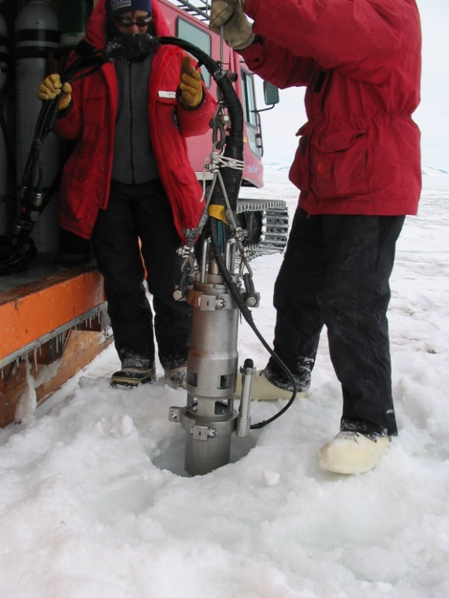
Montana Tech professor Marvin Speece (above left) and Montana Tech graduate student Seth Betterly (above right) helped plan this survey and collect these data. The 2005 ANDRILL Southern McMurdo Sound (SMS) seismic survey incorporated techniques that improved the quality of over-sea-ice seismic data (Speece et al., 2007; Betterly et al., 2007).
Advanced Electric Grid Control
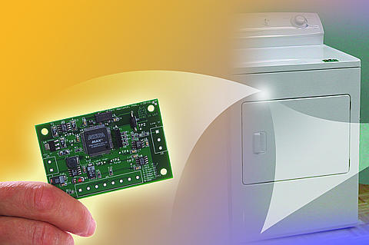
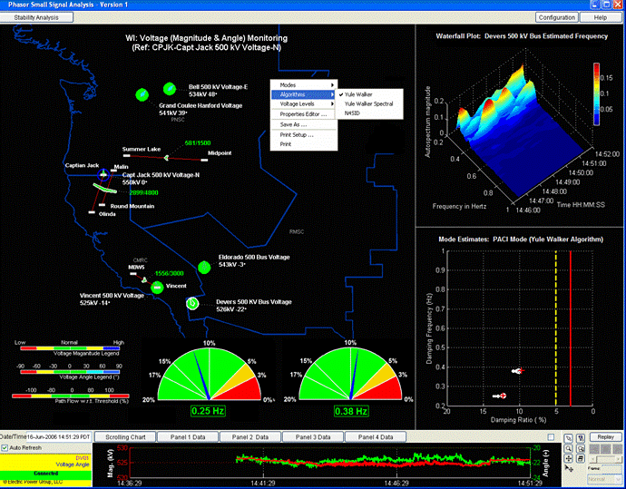
An efficient, reliable, and affordable electric-power grid continues to be critical to the economic and social health of the United States. Growing demand, lack of investment, and new national security requirements all point to the need for significant investment in upgrading the US power grid. Recent indicators of this include the significant increase in power outages over the last decade; these include the massive outages experienced by the western North American power system in August and July 1996, and the August 2003 east-coast power outage. These massive outages are the first since the northeast coast outage in 1965. Advanced control and new operating paradigms offer considerable benefits in terms of cost savings, reliability, and national security for the grid of the future.
The pictures show two manifestations of the future electric grid. The top illustration depicts a smart dryer that senses the condition of the grid and can reduce or eliminate its load to help stabilize a faulty grid. The second graphic illustrates a simulation of the northwest grid which tracks power flow and the frequency oscillations that are predictors of impending collapse.
Recognizing this potential, the USDOE has provided funding to Montana Tech to develop key technologies for applying real-time advanced control to improve grid reliability and efficiency. Our program is developing advanced control technologies for improving grid reliability and efficiency, facilitating deployment of these technologies to the industry, and educating the next generation of engineers in intelligent utilization and operation of electrical energy systems.

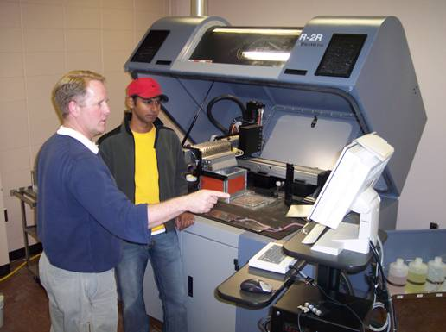
Titanium Fabrication
Military systems of the future will require improvements in transportability, maneuverability, stealth, and in durability. Free-form fabrication using titanium-based alloys shows promise to meet these objectives. However, current high costs associated with fabricating titanium-based alloys remain the main obstacle for widespread use as a material of construction.

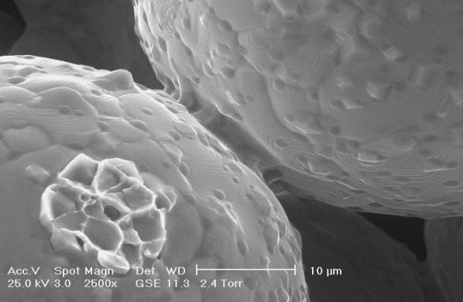
Montana Tech is exploring the use of free form fabrication technology based on fabrication with a three-dimensional printing machine shown above. This systemusesmetal powders and layer-by-layer deposition. The resultant assembly is then sintered at high temperatures giving the resultant micro structure shown. This method is a more economical titanium fabrication technique when it is compared to current casting methods and may be suitable for making titanium and titanium alloys as inexpensive commodity metals for general use, rather than as exotic materials to be used only when their high performance is required despite their present high cost.

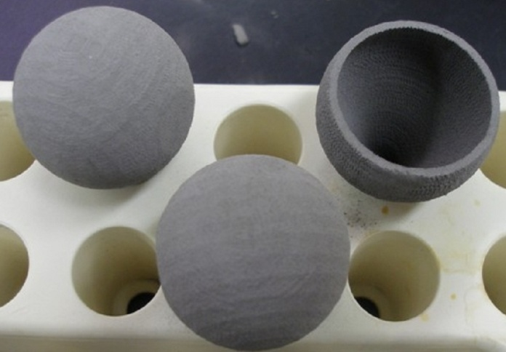
The US Navy is currently sponsoring a program to fabricate components for a low thermal and acoustic signature fuel cell power supply. Montana Tech is fabricating a novel H2 filter using free form technology to produce these light bulb sized components show at the right.

6. Summary of the most significant artistic creation, scholarly activity, and research by faculty during the past five years.
Biology

Kasinath, R.K. —K.H. Prakash, L. Grøndahl, R. Kumar, D. Martin and M. Trau, An Organic Matrix-Mediated Processing Methodology to Fabricate Hydroxyapatite based Nanostructured Biocomposites, Nanoscale, 2009, DOI: 10.1039/B9NR00062C, published online 8/12/2009.
Pedulla, M.L.—Pope, W.H.; Weigele, P.R.; Chang, J.; Pedulla, M.L.; Ford, M.E.; Houtz, J.M.; Jiang, W.; Chiu, W.; Hatfull, G.F.; Hendrix, R.W.; and King, J.; “Genomic and structural analysis of Syn9, a cyanophage infecting marine Prochlorococcus and Synechococcus,” Environmental Microbiology: In press.
Apple, M.— D. Olszyk, M. Apple, B. Gartner, R. Spicer, C. Wise, E. Buckner, A. Benson-Scott and D. Tingey. 2005. Xeromorphy increases in shoots of Pseudotsuga menziesii (Mirb.) Franco seedlings with exposure to elevated temperature but not elevated CO₂. Trees 19:552-563.
Liberal Studies
Ziegler, Robert. The Nothing Machine: The Fiction of Octave Mirbeau, Amsterdam: Presses Rodopi, 2007.
Ziegler, Robert. “Necrophilia and Authorship in Rachilde’s ‘La Tour d’amour.’” “Nineteenth-Century French Studies Vols. 3-4. Nos. 1-2 (Winter 2006-6): 134-145.
Ziegler, B. “The Mirror of Divinity: The World and Creation in J.-K. Huysmans”, Newark, DE: The University of Delaware Press, 2004 (book).
Engineering
Trudnowski, D., J. Pierre, N. Zhou, J. Hauer, and M. Parashar, “Performance of Three Mode-Meter Block-Processing Algorithms for Automated Dynamic Stability Assessment,” IEEE Transactions on Power Systems, vol. 23, no. 2, pp. 680-690, May 2008.
Trudnowski, D., M. Donnelly, and E. Lightner, “Power-System Frequency and Stability Control using Decentralized Intelligent Loads,” Proceedings of the 2005/2006 IEEE PES T&D Conference and Exposition, Dallas, TX, May 2006.
MacLaughlin, M. M. and D. M. Doolin (2006). Review of Validation of the Discontinuous Deformation Analysis (DDA) Method, International Journal for Numerical and Analytical Methods in Geomechanics, 30/4 (April 2006): pp 271-305

Global Warming

Speece, M. A. —Betterly, S. J., Speece, M. A., Levy, R. H., Harwood, D. M., and Henrys, S. A., A novel over-sea-ice seismic reflection survey in McMurdo Sound, Antarctica, Terra Antarctica, 14(2), 97-106 (2007).
Speece, M. A.—Pekar, S. F., Speece, M. A., Harwood, D. M., Florindo, F., and Wilson, G., 2007. Using new tools to explore undiscovered country: understanding the stratigraphic and tectonic history of greenhouse to icehouse worlds of offshore New Harbor, Ross Sea, Antarctica: in Cooper, A. K. and Raymond, C. R. et al (eds.)., A Keystone to a Changing World—Online Proceedings of the 10th ISAES, USGS Open-File Report 2007-1047, Extended Abstract 169, 4 pp.
Zhou, X., N.-B. Chang, and S. Li, "Detection of Coastal Region Sea Ice Decay from Orthorectified RADARSAT-1 ScanSAR Imagery: A Case Study of Bering Strait and Norton Sound, Alaska", Journal of Environmental Informatics, 10(1), 37-46, 2007.
Emerging Infectious Diseases
Kuenzi, A.J.—Calisher, C. H., K. D. Wagoner, B. R. Amman, J. J. Root, R. J. Douglass, A. J. Kuenzi, K. D. Abbott, C. Parmenter, T. L. Yates, T. G. Ksiazik, B. J. Beaty, and J. N. Mills. 2007. Demographic factors associated with prevalence of antibody to Sin Nombre virus in deer mice in the western United States. Journal of Wildlife Diseases 43:1-11.
Douglass, R.J.—Lonner, B, RJ Douglss, AJ Kuenzi and K. Huges. Seroprevalence Against Sin Nombre virus in Resident and Dispersing Deer Mice. Vector Borne and Zoonotic Diseases (In Press)
Large River Ecosystems

Gammons C.H.—Parker S. R., Gammons C. H., Poulson S. R., and DeGrandpre M. D. (2007) Diel changes in pH, dissolved oxygen, nutrients, trace elements, and the isotopic composition of dissolved inorganic carbon in the upper Clark Fork River, Montana, USA. Applied Geochemistry 22, 1329-1343

Weight, W. D.—Gammons, C.H., Slotten, D.G., Gerbrandt, B., Weight, W.D., Young, C.A., McNearny, R.L., Camac, E., Calderon, R., and Tapia, H. (2005). Mercury concentrations of fish, river water, and sediment in the Rio ramis-lake Titicaca watershed, Peru. Online at www.sciencedirect.com, Science of The Total Environment, Volume 368, Issues 2-3, 15 September 2006, Pages 637-648.
Zhou, X. —Makkeasorn, A., N. B. Chang, and X. Zhou, "Stream flow forecasting with the aid of NEXRAD, sea surface temperatures, and meteorological characteristics using genetic programming", Journal of Hydrology, in press
Medicinal Chemistry
Stierle, A., D.B. Stierle and K.Kelly. Berkelic acid, A Novel Spiroketal with Selective Anticancer Activity from an Acid Mine Waste Fungal Extremophile, 2006, Journal of Organic Chemistry, 71:5357-5360
Stierle, D.B.—Stierle, A.A.; Stierle, D.B.; Patacini, B.J. “The Berkeleyamides: Four Amides From the Acid Lake Fungus Penicillum rubrum”. J.Nat.Prod., in press.
Required Exhibits:
1. Faculty handbook, including personnel policies and procedures.

The Faculty Staff Handbook and Montana Tech Faculty Association (MTFA) and Vocational-Technical Educators of Montana (VTEM) Collective Bargaining Agreements (CBAs) can be found in the following exhibits:

- Exhibit 4.A.IX – MTFA-CBA, Montana Tech Faculty Association Collective
Bargaining Agreement;
- Exhibit 4.A.X – VTEM-CBA, Vocational-Technical Educators of Montana Collective
Bargaining Agreement; and
- Exhibit 4.A. XVI – Faculty Staff Handbook.

Personnel policies and procedures can be found in:

- Exhibit 4.A.XXII – Personnel Policies and Procedures.

2. Policy on Academic Freedom.

Montana Tech’s policies on academic freedom can be found in the following exhibits:

- Exhibit 4.A. XVI – Faculty Staff Handbook;
Section 202, Academic Freedom and Section 203, Faculty Code of Conduct
Section 203, Faculty Code of Conduct
- Exhibit 4.A.IX – MTFA-CBA, Article 9, Academic Freedom and Responsibility; and
- Exhibit 4.A.X – VTEM-CBA, Article 4.15, Academic Freedom.

These policies on academic freedom are based on the Montana Board of Regents Policy 302 (see Exhibit 4.A.XXVI –Montana Board of Regents Policy 302), which in turn is based on the 1940 Statement of Principles on Academic Freedom and Tenure of the American Association of University Professors and subsequent revisions (Exhibit 4.A.XXVII – AAUP 1940 Statement of Principles on Academic Freedom and Tenure).

3. Faculty Committees and Membership

Faculty participate actively on a large number of campus committees. Please see Exhibit 4.A.VI - 2009-2010 Committee Rosters.

4. Evaluation forms and summary reports of student evaluations of faculty and courses.

A copy of Montana Tech’s standardized student instructional evaluation form and a completed example of this evaluation form for a particular course are included in the following exhibits:

- Exhibit 4.A.XVII – Montana Tech Course Instruction Evaluation Form; and
- Exhibit 4.A.XVIII – Sample Real Course Evaluation.

Electronic access has also been provided for the Northwest Evaluation Team to the individual course evaluations for faculty in Exhibit 4.A.XIX – On-Line Access to Student Evaluations.

5. Access to personnel files and current professional vitae.

Personnel files and current standardized professional vitae are available in the exhibits:

- Exhibit 4.A. IV – Standardized Resumes of Full-Time Faculty; and
- Exhibit 4.A.V – Standardized Resumes of Part-Time Faculty.

6. Criteria and procedures for employing, evaluating, and compensating faculty in special programs such as off-campus, study aboard, travel/study, non-credit, or extension credit programs.

Montana Tech has had little to no involvement of faculty in study aboard, travel/study, non-credit, or extension credit programs. As a result, Montana Tech has developed no policies concerning faculty in these areas. However, the campus does teach some off-campus courses, notably the Business and Information Technology (BIT) program in Helena and several Jump-Start courses in Montana high schools. Faculty teaching in these courses are generally part-time faculty and are governed by the policies set forth for part-time faculty in the in The Faculty Staff Handbook (see Exhibit 4.A.XVI – Faculty Staff Handbook, Section 206.4 evaluation of part-time faculty.) Faculty teaching in the Jump-Start program are usually high school teachers who have a Master’s degree, who have their credentials and syllabus vetted by the appropriate Montana Tech department head, and who are only compensated if they teach outside of their normal school district contract hours.

7. Copies of any doctrinal statements required for employment, promotion, and tenure.

There are no doctrinal statements or loyalty oaths required for employment, promotion, or for tenure at Montana Tech.

8. Policies governing the employment, orientation, and evaluation of part-time faculty and teaching fellows, if applicable.

Procedures and expectations for recruitment, orientation, and evaluation of part-time faculty at Montana Tech are contained in the following exhibits:

- Exhibit 4.A.XXVIII – Part-Time Faculty Orientation Packet; and
- Exhibit 4.A.XVI – Faculty Staff Handbook, Section 206.4 evaluation of part-time faculty.

9. Summary reports of faculty involvement with public services/community services.
Faculty involvement in public/community service is detailed in each of the individual faculty resumes that can be found in exhibits:

- Exhibit 4.A.IV – Standardized Resumes of Full-Time Faculty; and
- Exhibit 4.A.V – Standardized Resumes of Part-Time Faculty.

Some of the more notable examples of public and community service by faculty are highlighted below:

- Dr. Jack Crowley, Associate Professor of Liberal Studies, is a Board member of Butte AIDS Support Services, an organization that provides the local community with information about AIDS prevention and offers testing for AIDS. He also volunteers for Butte Special Riders, an organization that provides a horseback riding program for handicapped children and teenagers.

- Dr. Suzan Gazioglu, Associate Professor of Mathematical Sciences, serves as a computer instructor for local senior citizens as part of Montana School District #1’s Retired and Senior Volunteer Program (RSVP) program.

- Richard Johnson, Associate Professor in General Engineering, is a search and rescue coordinator and licensed pilot.

- Steve Luft, instructor III, in Trades and Technical, is on the Board of Directors of the Southwest Montana Affiliate of Habitat for Humanity.

- Allison McIntosh, Associate Professor of Nursing, established and oversees a weekly Montana Tech Nursing Clinic at the Belmont Senior Center and at several public housing units in Butte. For this work, Allison was a finalist in 2004 for the Jimmy and Rosalyn Carter Partnership Award for Campus Community Collaboration in Montana.

10. Institutional policies regarding scholarship and artistic creation by faculty and students.

The Research Office has developed procedures and policies governing scholarship and artistic creation. These policies can be found in the following exhibits:

- Exhibit 4.B.VI – PI Training Info Packet;
Pre-Award Process
Post-Award Process
Intellectual Property and Technology Transfer
Conflict of Interest
- Exhibit 4.B.VII – Conflict of Interest Policy, Forms, and Definitions;
- Exhibit 4.B.XXVI – Research and Scholarly Activity Integrity Policy;
- Exhibit 4.B.XXVII – BOR Policy 401 – Research and Technology Transfer;
- Exhibit 4.B.XXVIII – BOR Policy 401.2 – Inventions and Patents;
- Exhibit 4.B.XXIX – Invention and Patent Policy;
- Exhibit 4.B.XXX – Invention and Patent Policy Disclosure Forms;
- Exhibit 4.B.XXXI – Student Patent Rights MOU;
- Exhibit 4.B.XXXII – Proposal Certification Form (PCF);
- Exhibit 4.B.XXXIII – PCF Form Instructions;
- Exhibit 4.B.XXXIV – Indirect Costs and Benefits;
- Exhibit 4.B.XXXV – IDC Policy;
- Exhibit 4.B.XXXVI – IDC Rate Agreement; and
- Exhibit 4.B.XXXVII – PI Handbook and Inserts.

11. Institutional policies regarding research activity, including sponsored research by faculty and students.

In addition to the exhibits detailing policies and procedures listed above under Standard 4 Required Exhibits, 4.10, several policies have been developed to guide student research. These policies can be found in the following exhibits:

- Exhibit 4.B.XIX – URP Statement of Purpose;
- Exhibit 4.B.XX – URP Guidelines; and
- Exhibit 4.B.XXI – URP Charter.

12. Summary of the faculty role in developing and monitoring policies and practices scholarship, artistic creation, and research.

Faculty involvement in developing and modifying policies that govern scholarship, artistic creation, and research occurs primarily through the activities of the Graduate Council and the Research Advisory Committee. The membership, mission statements, and meeting minutes for the last two years for these committees can be found in the following exhibits:

- Exhibit 4.B.XII – Graduate Council and Research Advisory Council Members;
- Exhibit 4.B.VIII – Graduate Council Mission Statement;
- Exhibit 4.B.X – Graduate Council Minutes;
Fall 2005, Fall 2006, Spring 2007, Fall 2007
- Exhibit 4.B. IX – Research Advisory Council Mission Statement; and
- Exhibit 4.B. XI – Research Advisory Council Minutes.
Fall 2005, Fall 2006, Fall 2007, Spring 2008

Faculty also direct the Montana Tech Seed Grant program, which provides a very modest amount of start up monies to faculty who are within two years of the date of their initial hire. The membership, policies, and recent activities of the Montana Tech Seed Grant program can be found in the following exhibits:

- Exhibit 4.B.XVI – Seed Grants Committee Members;
- Exhibit 4.B.XV – Seed Grants Program Mandate; and
- Exhibit 4.B.XVII – Recent Seed Grant Awards.

Suggested Materials:

Statistics on faculty retention and turnover

Table 4.A.VI in Section 4.A.4 of this self study presents retention data for the past four years by department and for Montana Tech as a whole. The data in this table show that Montana Tech has retained 94% of its faculty, averaged over a five-year period.

List of Exhibits:

4.A.1
Exhibit 4.A.I – Summary of Faculty Characteristics
Exhibit 4.A.II, Table 1 – Institutional Faculty Profile;
Exhibit 4.A.III, Table 2 –Number and Source of Terminal Degrees of Faculty
Exhibit 4.A. IV – Standardized Resumes of Full-Time Faculty
Exhibit 4.A.V – Standardized Resumes of Part-Time Faculty

4.A.2
Exhibit 4.A.VI – 2009-2010 Committee Roster
Exhibit 4.A.VII, Committee Minutes
Exhibit 4.A.VIII – Example Curriculum Review Request
Exhibit 4.A.IX – MTFA-CBA, Montana Tech Faculty Association Collective
Bargaining Agreement
Exhibit 4.A.X – VTEM-CBA, Vocational-Technical Educators of Montana Collective
Bargaining Agreement

4.A.3
Exhibit 4.A.IX – MTFA-CBA, Article 21, Workload
Exhibit 4.A.X, VTEM-CBA, Appendix C - Memorandum of Understanding Faculty
Workload
Exhibit 4.A.XI – Montana Tech Course Schedules

4.A.4
Exhibit 4.A.II, Table 1 – Institutional Faculty Profile
Exhibit 4.A.XII – Faculty Salary Data
Exhibit 4.A.XIII – Merit Plan
Exhibit 4.A.XIV –Research Salary Policy
Exhibit 4.A.XV – Montana State University Board of Regents Policy 404.1, Consulting Services – Faculty

4.A.5
Exhibit 4.A. XVI – Faculty Staff Handbook,
Section 206, Evaluation, Promotion, and Tenure – North Campus Faculty
Section 207, Evaluation, Promotion, and Tenure –COT Faculty
Section 208. Classification and Promotion - Montana Bureau of Mines and Geology Professional Faculty and Staff
Section 206.4 evaluation of part-time faculty
Exhibit 4.A.IX – MTFA-CBA, Article 14, Faculty Evaluation
Exhibit 4.A.X – VTEM-CBA, Article 7, Faculty Evaluation
Exhibit 4.A.XVII – Montana Tech Course Instruction Evaluation Form
Exhibit 4.A.XVIII – Sample Real Course Evaluation
Exhibit 4.A.XIX – On-Line Access to Student Evaluations
Exhibit 4.A.XX – Faculty Promotion and Tenure Portfolio
Exhibit 4.A.XXI – The Departmental Standards are an appendix to Exhibit 2.A.I,
Program Reviews.

4.A.6
Exhibit 4.A.XXII – Personnel Policies and Procedures.
Exhibit 4.A. XVI – Faculty Staff Handbook,, Section 204, Recruiting and Selecting New Faculty; Section 501, Hiring Procedures
Exhibit 4.A.IX – MTFA-CBA, Article 10, Recruiting and Selecting of New Faculty
Exhibit 4.A.X – VTEM-CBA, Article 9.5, Extended Postings and Hiring Between Colleges
Exhibit 4.A.XXIII – PRA Form
Exhibit 4.A.XXIV – Example PRA
Exhibit 4.A.XXV – Montana Tech Employment Web Site
Exhibit 4.A.XVI – Faculty Staff Handbook, Section 501, Relocation Expenses

4.A.7
Exhibit 4.A. XVI – Faculty Staff Handbook,
Section 202, Academic Freedom and Section 203, Faculty Code of Conduct
Section 203, Faculty Code of Conduct
Exhibit 4.A.XXVI – Montana Board of Regents Policy 302
Exhibit 4.A.XXVII –AAUP 1940 Statement of Principles on Academic Freedom and Tenure
Exhibit 4.A.IX – MTFA-CBA, Article 9, Academic Freedom and Responsibility
Exhibit 4.A.X – VTEM-CBA, Article 4.15, Academic Freedom

4.A.8

Exhibit 4.A. XVI – Faculty Staff Handbook, Section 204, Recruiting and Selecting Part-Time Faculty
Exhibit 4.A.II, Table 1 – Institutional Faculty Profile
Exhibit 4.A.III, Table 2 – Number and Source of Terminal Degrees of Faculty
Exhibit 4.A.V – Standardized Resumes of Part-Time Faculty

4.A.9

Exhibit 4.A.XXVIII – Part-Time Faculty Orientation Packet
Exhibit 4.A.XVI – Faculty Staff Handbook, Section 206.4 evaluation of part-time faculty

4.A.10

Exhibit 4.A.XXVIII – Part-Time Faculty Orientation Packet

4.B.1
Exhibit 4.B.I – Research Annual Progress Report FY2006 and FY 2007
Exhibit 4.B.II – Research Annual Progress Report FY2005
Exhibit 4.B.III – Research Annual Progress Report FY2004
Exhibit 4.B.IV – Research Annual Progress Report FY2003
Exhibit 4.B.V – List of Published Scholarly Work (1999-2008)

4.B.2
Exhibit 4.B.VI – PI Training Info Packet
Pre-Award Process
Post-Award Process
Intellectual Property and Technology Transfer
Conflict of Interest
Exhibit 4.B.VII – Conflict of Interest Policy, Forms, and Definitions

4.B.3
Exhibit 4.B.VIII – Graduate Council Mission Statement
Exhibit 4.B. IX – Research Advisory Council Mission Statement
Exhibit 4.B.X – Graduate Council Minutes;
Fall 2005, Fall 2006, Spring 2007, Fall 2007
Exhibit 4.B. XI – Research Advisory Council Minutes;
Fall 2005, Fall 2006, Fall 2007, Spring 2008
Exhibit 4.B.XII – Graduate Council and Research Advisory Council Members

4.B.4
Exhibit 4.B.XIII – Office off Research Organization Structure
Exhibit 4.B.XIV – Office of Contracts and Grants Organization Structure
Exhibit 4.B.XV – Seed Grants Program Mandate
Exhibit 4.B.XVI – Seed Grants Committee Members
Exhibit 4.B.XVII – Recent Seed Grant Awards

4.B.5
Exhibit 4.B.XVIII – Distinguished Researcher Award Policy, Process, and Winners

4.B.6
Exhibit 4.B.XIX – URP Statement of Purpose
Exhibit 4.B.XX – URP Guidelines
Exhibit 4.B.XXI – URP Charter
Exhibit 4.B.XXII – URP Recent Awards List (2007-08, 2006-07, 2005-06)
Exhibit 4.B.XXIII – List of Research Proposals Submitted and Funded;
2004, 2005, 2006, 2007, 2008
Exhibit 4.B.XXIV –Board of Regents Policy on Research Centers and Programs
Exhibit 4.B.XXV – Research Centers Mission Statements

Other Exhibits Include:
- Exhibit 4.B.XXVI – Research and Scholarly Activity Integrity Policy
- Exhibit 4.B.XXVII – BOR Policy 401 – Research and Technology Transfer
- Exhibit 4.B.XXVIII – BOR Policy 401.2 – Inventions and Patents
- Exhibit 4.B.XXIX – Invention and Patent Policy
- Exhibit 4.B.XXX – Invention and Patent Policy Disclosure Forms
- Exhibit 4.B.XXXI – Student Patent Rights MOU
- Exhibit 4.B.XXXII – Proposal Certification Form (PCF) and
- Exhibit 4.B.XXXIII – PCF Form Instructions
- Exhibit 4.B.XXXIV – Indirect Costs and Benefits
- Exhibit 4.B.XXXV – IDC Policy
- Exhibit 4.B.XXXVI – IDC Rate Agreement
- Exhibit 4.B.XXXVII – PI Handbook and Inserts

Policy 4.1

Exhibit 4.A. XVI – Faculty Staff Handbook,
Section 206, Evaluation, Promotion, and Tenure – North Campus Faculty;
Section 207, Evaluation, Promotion, and Tenure –COT Faculty
Section 208. Classification and Promotion - Montana Bureau of Mines and Geology Professional Faculty and Staff;
Section 206.4 evaluation of part-time faculty;
Appendix B – Tenure Progress Report (Dept Faculty);
Appendix C – Tenure Progress Report (Dept Head)
Exhibit 4.A.IX – MTFA-CBA, Article 14, Faculty Evaluation;
Exhibit 4.A.X – VTEM-CBA, Article 7, Faculty Evaluation
Exhibit 4.A.XIX –On-Line Access to Student Evaluations
Exhibit 4.A.XX – Faculty Promotion and Tenure Portfolio
Exhibit 4.A.XVII – Montana Tech Course Instruction Evaluation Form

List of Tables and Figures:

4.A
TABLE 4.A.I Qualifications and Commitment of the Faculty
TABLE 4.A.II Degrees of Tenure Track Instructional Faculty by Department
Table 1, Institutional Faculty Profile
Table 2, Number and Source of Terminal Degrees of Faculty
TABLE 4.A.III Faculty Participation in Standing Committees
Table 4.A.IV Comparison of Montana Tech Salaries with CUPA
Table 4.A.V Salary Increases for Promotion and Academic Achievement
Table 4.A.VI Faculty Retained from the Previous Fall

4.B
Figure 4.A.1 – Portfolio Flow Sheet
Figure 4.B.1 – Total Grant Awards Received FY2004-2008
Figure 4.B.2 – Research Expenditures FY2004-2008
Figure 4.B.3 – Grant Writing Activity for Fiscal Years 2004 to 2008
Figure 4.B.4 – Campus Involvement in Research
Figure 4.B.5 – Publishing Activity

